Winter Vaccination Toolkit
We can work together this winter to protect the most vulnerable members of our community and the people who work through vaccination, which prevents serious illness and hospitalisation from virus like flu and Covid-19.
Within this toolkit you will find communications resources to help you promote Covid-19 and flu vaccinations to staff and the general public.
What’s included?
- social media assets and copy for the general public and staff
- sets of posters and leaflets aimed at staff and patients/visitors
- eSignatures and stickers for staff
- videos and digital displays for screens for use in social care settings

Social media toolkit
Topic | Copy | Graphic
Adult winter vaccines | Are you eligible for a COVID-19 and flu vaccine this winter? Protect yourself ahead of the winter months when viruses spread more quickly. To book your free vaccination, visit www.nhs.uk | 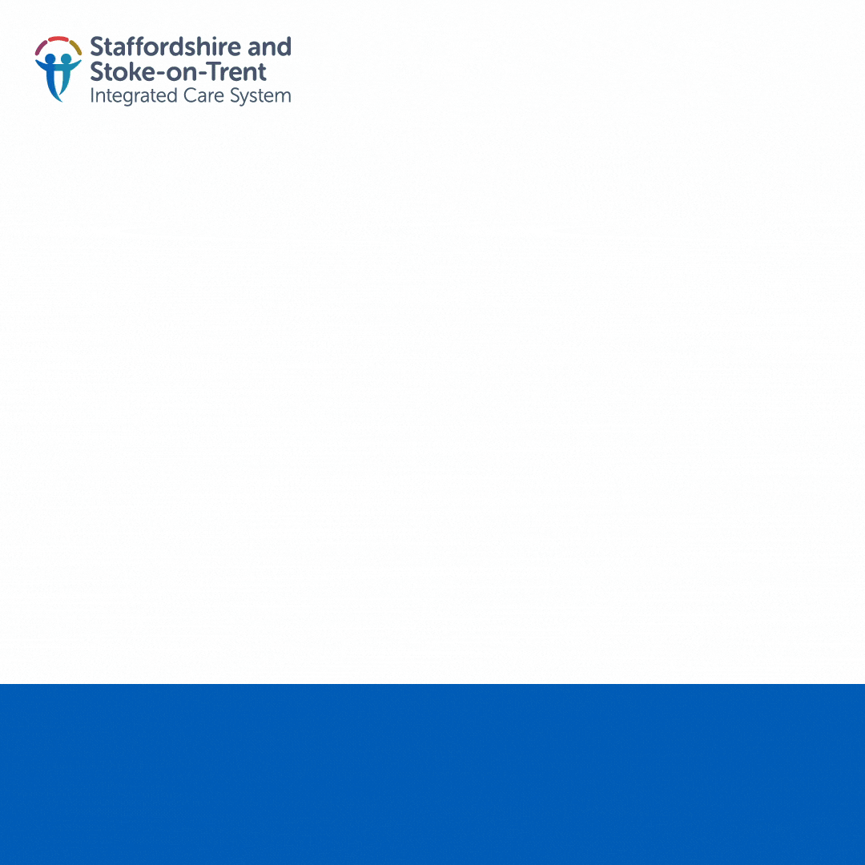  Winter-vaccine-gif (1080×1080) (icb.nhs.uk)
Adult winter vaccines | People aged 65+, front line health and social care workers and pregnant women are eligible for their free flu and COVID-19 vaccination. Top up your protection ahead of the winter months and book your appointment online today- www.nhs.uk | 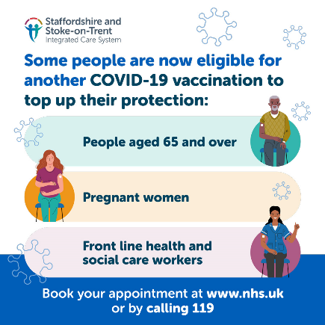  Winter Vaccine social media assets ICS v1
Adult winter vaccines | If you are a front-line health and social care worker, or if you work in a care home, you can now book your free winter vaccinations. Keep yourself and those around you protected from viruses like flu and COVID-19 this winter. To book your appointment, visit www.nhs.uk | 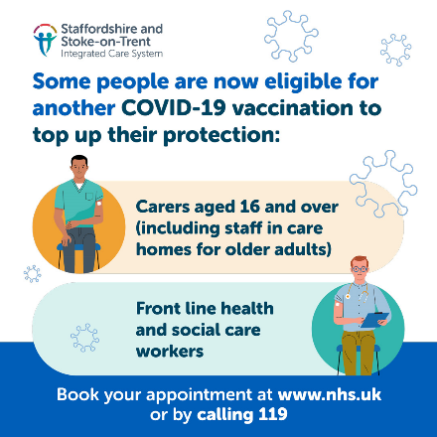  Winter Vaccine social media assets ICS v2
Immunosuppressed | Are you undergoing treatment such as chemotherapy or radiotherapy? Do you have diabetes, severe asthma, or heart, liver or kidney disease? If you do, you can now have COVID-19 and flu vaccinations to protect you against illness this winter. Book your appointment now online at www.nhs.uk or calling 119 | 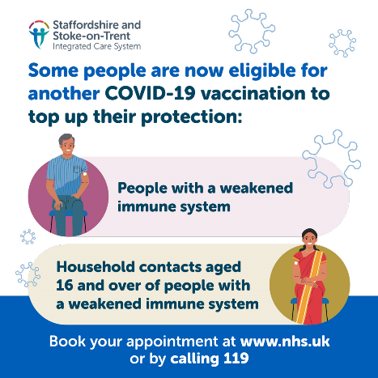  Winter Vaccine social media assets ICS v3
Adult winter vaccinations | If you are eligible, it is important to top up your protection this winter. Immunity fades over time and flu and COVID-19 viruses change each year. For more information, visit www.nhs.uk | 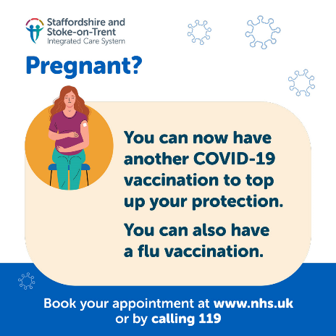  Winter Vaccine social media assets ICS v4
Adult winter vaccinations | Are you up to date with your winter vaccinations? Protect yourself from viruses like COVID-19 and flu ahead of the winter months when viruses spread more quickly. To find out if you’re eligible, visit www.nhs.uk | 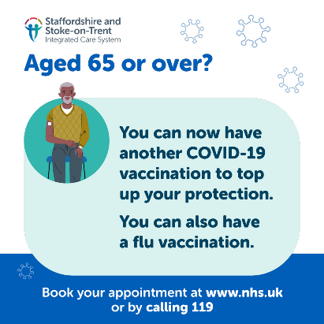  Winter Vaccine social media assets ICS v5
Adult winter vaccines | Flu and COVID-19 vaccinations are being offered to people who are most at risk of getting seriously ill this winter. To find out if you’re eligible, visit- https://www.nhs.uk/conditions/covid-19/ | 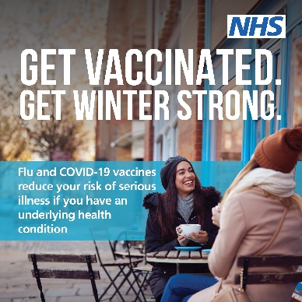  Click to download-  Social asset- Get Vaccinated General Clinical risk groups
Adult winter vaccines | If eligible, you will be invited to get your free winter vaccine by the NHS via text, email or letter, or you can book your vaccinations here- www.nhs.uk/covid-vaccination | 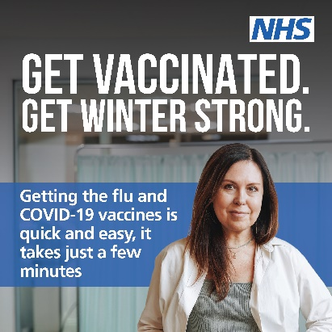  Click to download-  Social asset- Get Vaccinated General Convenience
Adult winter vaccines | Flu and COVID-19 vaccinations are being offered to people most at risk of getting seriously ill this winter.  To find out if you’re eligible, visit-  https://www.nhs.uk/conditions/covid-19/ | 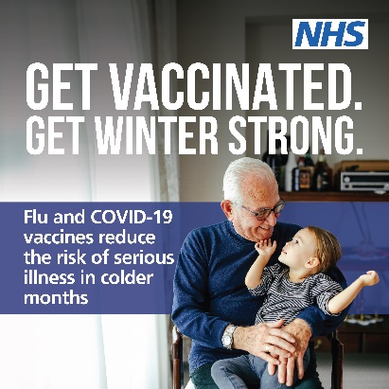  Click to download-  Social asset- Get Vaccinated General Core benefit 1
Adult winter vaccines | If you are eligible, it is important to top up your protection this winter. Immunity fades over time and flu and COVID-19 viruses change each year. | 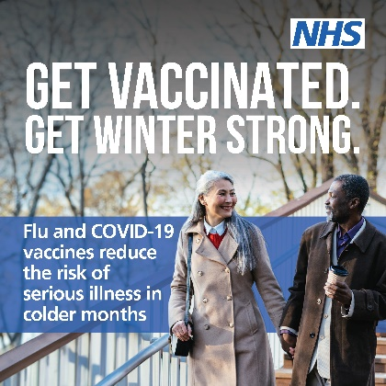  Click to download-  Social asset- Get Vaccinated General Core benefit 2
Paid and unpaid carers-  winter vaccines | If you are a paid or unpaid carer, you can book a flu and COVID-19 vaccine through your GP practice, local pharmacy or by visiting- www.nhs.uk/book-a-flu-vaccination | 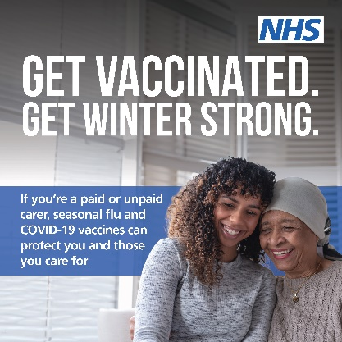  Click to download-  Social asset- Get Vaccinated General Carers
General winter vaccinations | Flu and COVID-19 vaccinations are being offered to people who are most at risk of getting seriously ill this winter. To find out if you’re eligible, visit- https://www.nhs.uk/conditions/covid-19/ | 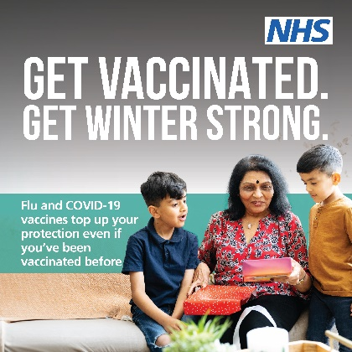  Click to download-  Social asset- Get Vaccinated General; Why get vaccinated?
Children Winter Vaccines | Is your child up to date with their winter vaccinations?  Keep them protected from flu by ensuring your child is vaccinated. To find out more, visit nhs.uk/vaccinations/booking-your-childs-vaccination | 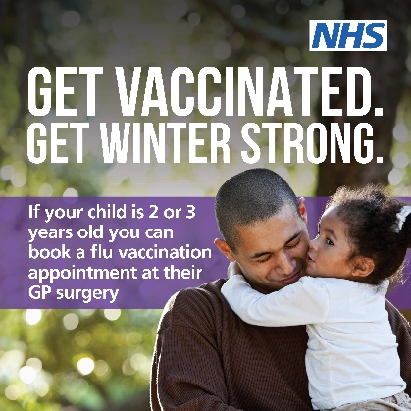  Click to download-  Social asset- Get Vaccinated Toddlers 2
Children Winter Vaccines | Is your child up to date with their winter vaccinations?  Keep them protected from flu this winter. For more info, visit nhs.uk/vaccinations/booking-your-childs-vaccination | 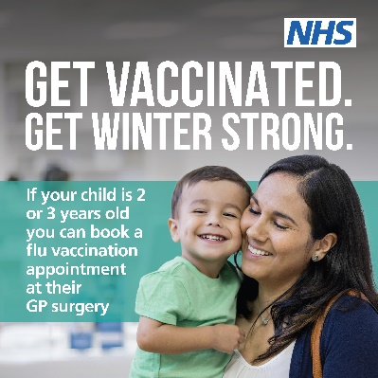  Click to download:  Social asset- Get Vaccinated Toddlers 3
Children Winter Vaccines | Is your child up to date with their winter vaccinations?  Keep them protected from flu by ensuring your child is vaccinated. For more info, visit nhs.uk/vaccinations/booking-your-childs-vaccination | 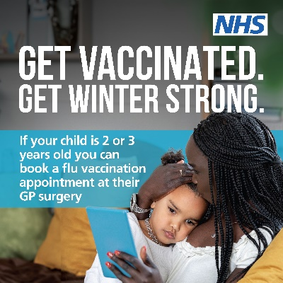  Click to download:  Social asset- Get Vaccinated Toddlers 1
Vaccinations in pregnancy | Getting vaccinated is the safest and most effective way for women to protect themselves and their baby against COVID-19 and flu this winter. For more information, vist- https://www.nhs.uk/pregnancy/keeping-well/ | 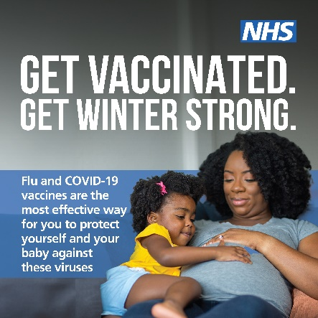  Click to download-  Social asset- Get Vaccinated Pregnant 1
Vaccinations in pregnancy | You can have the flu vaccine at any stage of pregnancy, from the first few weeks up to your expected due date, and if you are breastfeeding. To find out more about winter vaccinations in pregnancy, visit- https://www.nhs.uk/pregnancy/keeping-well/ | 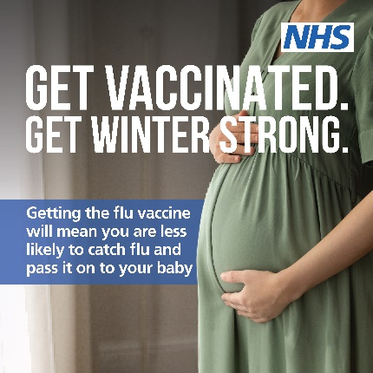  Click to download-  Social asset- Get Vaccinated Pregnant 2
Example of staff tailored assets | Are you a GP?  You are eligible, and it is important to top up your protection this winter, even if you have already had a vaccine. | NHSE Winter Vacc Asset 1 GP  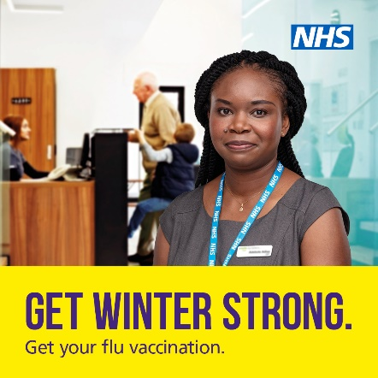

Download the social assets from the above table here:
Staffordshire and Stoke-on-Trent specific social media assets
Winter Vaccine social media assets ICS v1
Winter Vaccine social media assets ICS v2
Winter Vaccine social media assets ICS v3
Winter Vaccine social media assets ICS v4
Winter Vaccine social media assets ICS v5
Winter-vaccine-gif (1080×1080) (icb.nhs.uk)

Social asset- Get Vaccinated General Carers
Social asset- Get Vaccinated General Clinical risk groups
Social asset- Get Vaccinated General Convenience
Social asset- Get Vaccinated General Core benefit 1
Social asset- Get Vaccinated General Core benefit 2
Social asset- Get Vaccinated General; Why get vaccinated?
Social asset- Get Vaccinated Pregnant 1
Social asset- Get Vaccinated Pregnant 2
Social asset- Get Vaccinated Toddlers 1
Social asset- Get Vaccinated Toddlers 2
Social asset- Get Vaccinated Toddlers 3

The following assets can be downloaded and shared with relevant staff members:
NHSE Winter Vacc Asset 1 GP
NHSE Winter Vacc Asset 2 Healthcare
NHSE Winter Vacc Asset 3 Nurse
NHSE Winter Vacc Asset 4 Paramedic
NHSE Winter Vacc Asset 5 Pharmacist
NHSE Winter Vacc Asset 6 Porter

Posters
Staffordshire and Stoke-on-Trent specific posters
Are you pregnant? Vaccination poster (icb.nhs.uk)
Do you have a weakend immune system? Vaccination poster (icb.nhs.uk)
Some people are eligible for another COVID-19 vaccination poster (icb.nhs.uk)

Winter strong posters for long term health conditions
Long term health1 Flu COVID Vaccination Poster A4 LTH 01
Long term health1 Flu COVID Vaccination Poster A4 LTH 02
Long term health1 Flu COVID Vaccination Poster A4 LTH 03
Long term health1 Flu COVID Vaccination Poster A4 LTH 04

Winter strong posters for Over 65’s
Over 65 01 Flu COVID Vaccination Poster A4
Over 65 02 Flu COVID Vaccination Poster A4
Over 65 03 Flu COVID Vaccination Poster A4
Over 65 04 Flu COVID Vaccination Poster A4

Winter strong posters for parents
Parents 01 Flu COVID Vaccination Poster A4
Parents 02 Flu COVID Vaccination Poster A4
Parents 03 Flu COVID Vaccination Poster A4

ZIP folder- general public facing posters (to share digitally, or print and display)

The following posters can be used within the relevant type of social care setting:
NHSE Poster A4 1 GP
NHSE Poster A4 2 Healthcare
NHSE Poster A4 3 Nurse
NHSE Poster A4 4 Paramedic
NHSE Poster A4 5 Pharmacist
NHSE Poster A4 6 Porter
Paid and unpaid carers- winter vaccinations poster version 1
Paid and unpaid carers- winter vaccinations poster version 2
UKHSA Easy Read poster about the flu vaccination
‘Dear visitors’ poster for care homes
Pregnancy flu vaccination version 1
Pregnancy flu vaccination version 2

Translated posters (eligibility for COVID-19 and flu vaccinations) in the following languages:
Slovak
Russian
Urdu
Turkish
Arabic
Gujarati
Albanian
Romanian
Farsi
Lithuanian
Portuguese
Polish
Greek
Latvian
Punjabi
Hungarian

Web banners
Web banner – general COVID-19 and Flu
Web banner – parents

Digital screen displays
General public facing displays for digital screens

The following digital screen displays can be used within the relevant type of social care setting:
NHSE DigiScreen 1 GP
NHSE DigiScreen 2 Healthcare
NHSE DigiScreen 3 Nurse
NHSE DigiScreen 4 Paramedic
NHSE DigiScreen 5 Pharmacist
NHSE DigiScreen 6 Porter
Carer winter vaccinations- AV screen version 1
Carer winter vaccinations- AV screen version 2
Pregnant women and flu vaccinations AV screen

Leaflets and stickers
Leaflet A5 Healthcare Frontline Staff
Leaflet A5 Healthcare Care worker
Flu vaccination: who should have it this winter and why
Translated versions in various languages available here- https://www.gov.uk/government/publications/flu-vaccination-who-should-have-it-this-winter-and-why
A guide to the COVID-19 autumn programme
Translated versions in various languages available here- https://www.gov.uk/government/publications/covid-19-vaccination-autumn-booster-resources
Stickers- Winter Strong

eSignatures for staff use
NHSE eSignature 1 GP
NHSE eSignature 2 Healthcare
NHSE eSignature 3 Nurse
NHSE eSignature 4 Paramedic
NHSE eSignature 5 Pharmacist
NHSE eSignature 6 Porter

NHS COVID-19 Vaccination Q&As to support conversations with the public
COVID-19 Vaccination Q+As- Click to download

Videos for carers and care home residents:
Dr Nikki Kanani urges all paid and unpaid carers to get their flu & COVID-19 jabs- https://www.youtube.com/shorts/60s1gdZLLwQ
Simple video – flu vaccination Simplified video about the flu vaccination- click to watch
NHS England: Flu can be fatal
https://www.youtube.com/watch?v=15pieb-313o

UKHSA Flu Resources
Leaflet on flu for adults, parents and pregnant people
Child flu leaflets and posters
GP template letter for inviting 2-3s
Easy read posters and leaflets on flu
Simple text flu leaflets for adults and children
Digital Screen Saver
Child flu vaccination poster 1- book now
Child flu vaccination poster 1- wait to book
Child flu vaccination poster 2- book now
Child flu vaccination poster 2- wait to book

Resources to support the MMR vaccination
MMR secondary school immunisation poster A3
MMR secondary school postcard

Other useful information / links:
- NHS COVID-19 Vaccination Q&As to support conversations with residents: COVID-19 Vaccination Q+As- Click to download
- Helping to prevent Infection: A quick guide for managers and staff in care homes:
- Helping to prevent infection: A quick guide for managers and staff in care homes (NICE)
- NHS press release- roll out of the Winter Vaccination Programme kicks off with care homes: https://www.england.nhs.uk/2023/09/nhs-winter-vaccine-rollout-kicks-off-with-care-homes/
- DHSC/UKHSA announcement: https://www.gov.uk/government/news/flu-and-covid-autumn-vaccine-programmes-brought-forward
- Further guidance for pregnant women on getting flu, COVID-19 and pertussis (whooping cough) vaccinations in their local area- Vaccinations in pregnancy - NHS (www.nhs.uk).

