Social Channel | Copy | Graphic
Facebook/ LinkedIn/  Twitter | Measles cases are rising in England. Make sure your child is up to date with their MMR vaccinations.  For more information visit nhs.uk/mmr | 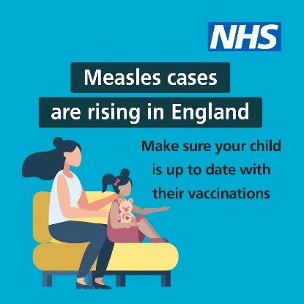
Facebook/ LinkedIn/  Twitter | Two doses of the MMR vaccinations can help stop your child becoming seriously unwell with measles.  For more information on how to check your child’s vaccination record, visit nhs.uk/mmr | 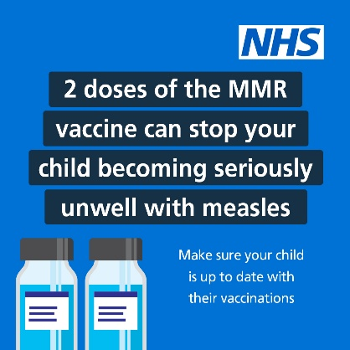
Facebook/ LinkedIn/  Twitter | Measles cases are rising in England.  You can ask your GP practice for the MMR vaccine if your child has missed either of these 2 doses.  For more information visit nhs.uk/mmr | 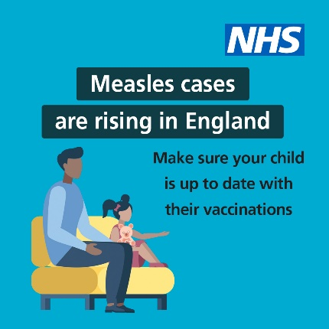
Facebook/ LinkedIn/  Twitter | Measles – are you protected? For lifelong protection, you need 2 doses of the #MMR vaccine.  If not, you could be at risk –contact your GP to get up to date. | 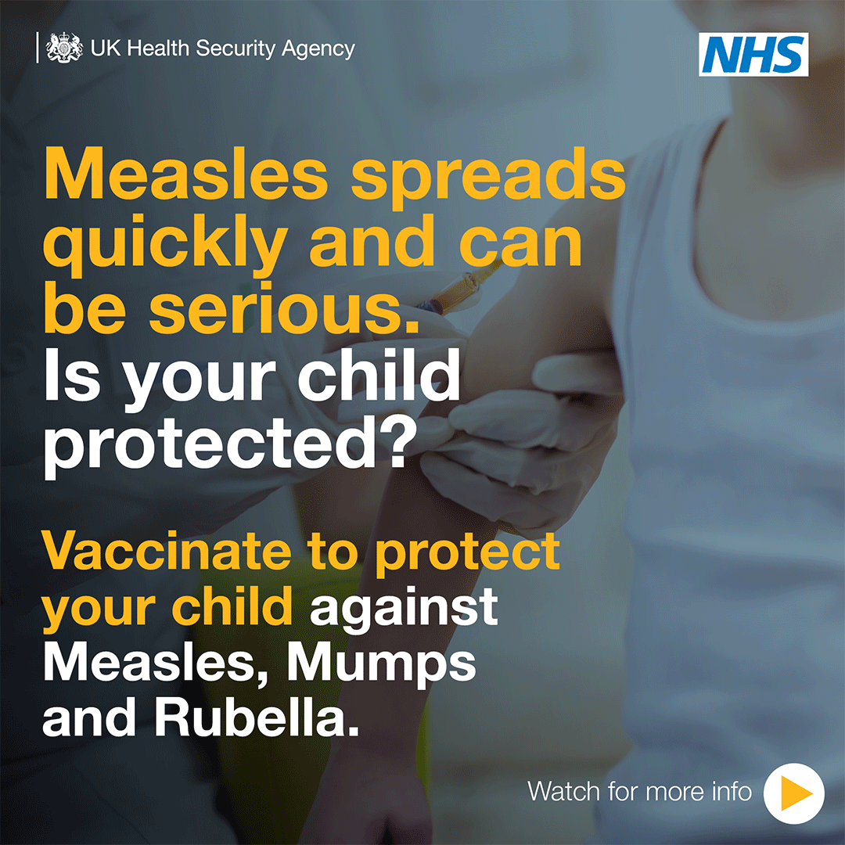
Facebook/ LinkedIn/  Twitter | To get lifelong protection against measles you need to have 2 doses of the #MMR vaccine. If you think you or a loved one isn’t up to date, contact your GP to get up to date. | 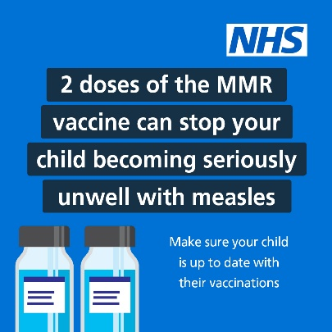
Facebook/ LinkedIn/  Twitter | Did you know? 15 minutes with someone who had measles is enough time for the virus to be passed on.  Make sure you’re up to date with #MMR vaccinations.  For more information visit nhs.uk/mmr | 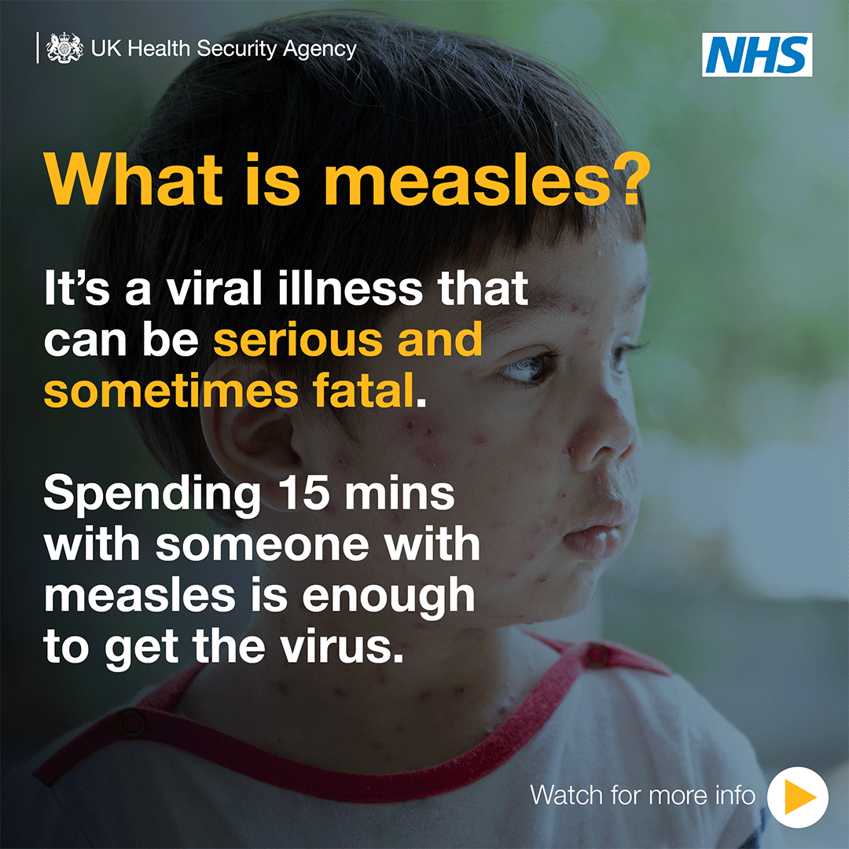
Facebook/ LinkedIn/  Twitter | Measles can have serious or sometimes fatal consequences and is still common in many countries worldwide. Make sure you & your loved ones are up to date with #MMR vaccinations.  Measles can have serious or consequences and is still common in many countries worldwide. Make sure you are up to date with #MMR vaccinations. | 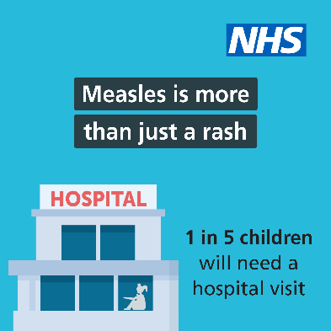
Back to school
Facebook/ LinkedIn/  Twitter | Has your child started primary school this September?  Check to see if your child is up to date with their MMR vaccine to protect them against catching measles. | 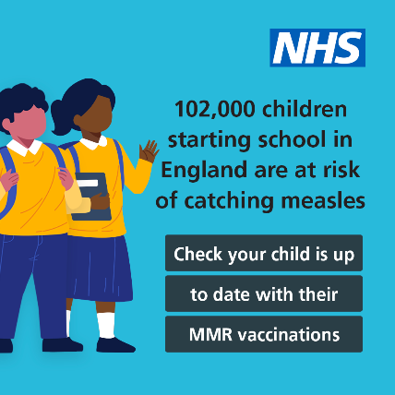
Facebook/ LinkedIn/  Twitter | Has your child started secondary school this September?  Check to see if your child is up to date with their MMR vaccine to protect them against catching measles. | 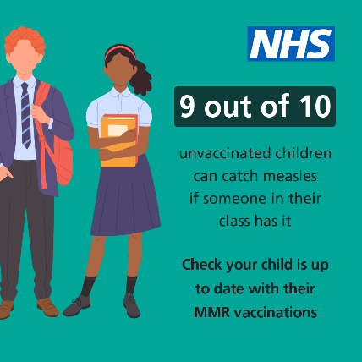
Facebook/ LinkedIn/  Twitter | Measles is highly infectious and can be passed on even before the rash appears.  Make sure your child is protected from becoming seriously unwell.

Back to school MMR resources (UKHSA)
MMR primary school children- Social asset
MMR Secondary school children- Social asset
MMR secondary school immunisation poster A3
MMR secondary school postcard
MMR Back to primary school poster A3
MMR Back to primary school postcard
MMR Back to nursery poster A3
MMR Back to nursery postcard

MMR vaccine social assets to download
Asset 1- Measles- More than just a rash
Asset 2- Measles Travel
Asset 3- Measles Travel 2
Asset 4- Cases are rising
Asset 5- Cases are rising 2
Asset 6- 1 in 5
Asset 7- Get two doses
GIF 1 Measles symptoms
GIF 2 Measles is your child protected
Call to Action if you have symptoms

UKHSA communications toolkit
This toolkit, created by UKSHA, is to support partners with managing local and regional communications and to signpost to the latest materials. This toolkit also includes links to UKHSA blogs which you can link within your own internal and external communications. Download the toolkit here.

UKHSA MMR programme publications presentation
This presentation includes a range of materials available to download or to order, along with translated materials and posters for those with low literacy, also available in translations. You can view and download the presentation here.

National UKHSA letter for professional health organisations
Click here to download the official UKHSA letter for professionals

UKSHA poster for healthcare workers
This poster is for recognising and managing suspected cases, which has pictures of measles rashes on different skin tones. Click here to download.

More resources
MMR vaccine animation:
This animation was co-created with the British Society for Immunology and explains how vaccines work, to help parents and carers in making informed decisions about consent or when discussing routine vaccinations with their families and children and young people. It should not be marketed directly at Children and Young People.
Do you know how vaccines work? Click to view on YouTube

Know the symptoms- Video with Voiceover:
This can be shared on social media or in communications to educate the public on what symptoms of measles might look like.
Know the symptoms of Measles - Video with voiceover

MMR vaccine video animation:
Do you have symptoms of measles? This animation explains what symptoms might look like and what to do if you have them.

A leaflet to remind you to get your child immunised at one year of age- translated materials:

https://www.gov.uk/government/publications/immunisations-between-12-and-13-months-of-age

Available to download in the following languages: Afrikaans, Arabic, Bengali, Cantonese, Chinese, French, Italian, German, Hebrew, Hindi, Lithuanian, Polish, Portuguese, Romani, Romanian, Swahili, Spanish, Turkish, Tagalog, Tamil, Ukrainian and Urdu.

Measles information for schools and healthcare centres- translated materials:
https://www.healthpublications.gov.uk/ViewArticle.html?sp=Smeaslesdontletyouchildcatchitflyerforschoolstranslations
Available to download in the following languages: Afrikaans, Arabic, Bengali, Cantonese, Chinese, French, Italian, German, Hebrew, Hindi, Lithuanian, Polish, Portuguese, Romani, Romanian, Swahili, Spanish, Turkish, Tagalog, Tamil, Ukrainian and Urdu.

Useful links

A guide to vaccinations from 2 to 5 years: Details of immunisations for children between 2 and 5 years, before they start school

https://www.gov.uk/government/publications/pre-school-vaccinations-a-guide-to-vaccinations-from-2-to-5-years

Blog: What do I need to know about the MMR vaccine?
What do I need to know about the MMR vaccine? - UK Health Security Agency (blog.gov.uk)

Blog: Ensuring every child gets the best start in life – starting with vaccine protection
https://ukhsa.blog.gov.uk/2021/08/05/ensuring-every-child-gets-the-best-start-in-life-starting-with-vaccine-protection/

