Newsletter Copy
World Diabetes Day 2022 – Monday 14th November
Being diagnosed early is so important for all types of diabetes. It is important that everyone knows the signs to look out for and you know your risk of developing Type 2 diabetes. Type 2 diabetes is two to four times more likely in people of South Asian descent and Black Caribbean or Black African descent.
You can find out if you are at risk by visiting riskscore.diabetes.org.uk

Social media toolkit
Please use these hashtags: #Diabetes #WorldDiabetesDay and #RewriteTheStory
You can find more information on World Diabetes Day here
You can follow the activity on our social media channels here:

Twitter: https://twitter.com/StaffsStokeICb
Facebook: https://www.facebook.com/StaffsStokeICB/

Date to post | Copy | Image
13.11.22 | Being diagnosed early is so important for all types of #diabetes.  Make sure you know the signs to look out for and you know your risk of developing Type 2 diabetes.  #WorldDiabetesDay2022  #RewriteTheStory | 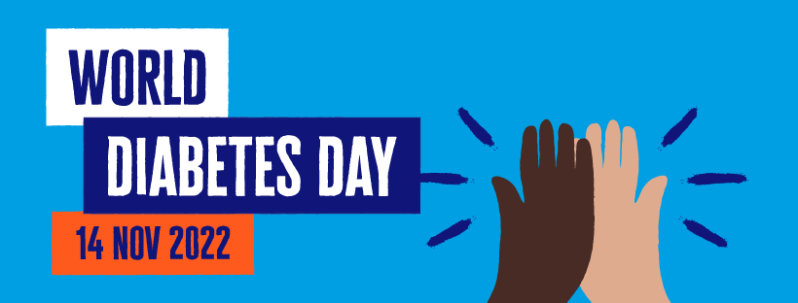
13.11. 22 | Finding out your risk of Type 2 diabetes only takes a few minutes. It could be the most important thing you do today....  By completing this tool, you may be eligible for the Healthier You NHS Diabetes Prevention Programme.  Visit riskscore.diabetes.org.uk  #Diabetes  #RewriteTheStory | 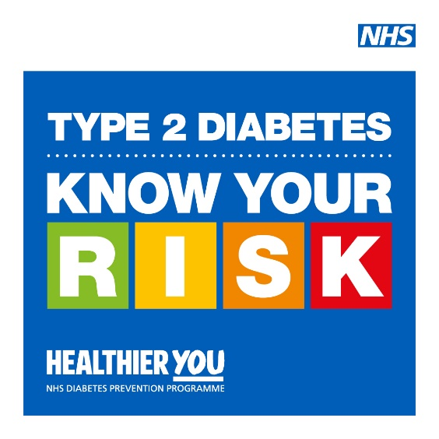
13.11.22 | Type 2 diabetes is two to four times more likely in people of South Asian descent and Black Caribbean or Black African descent.  That’s why it’s really important that you find out if you are at risk.  Visit riskscore.diabetes.org.uk  #Diabetes  #RewriteTheStory | 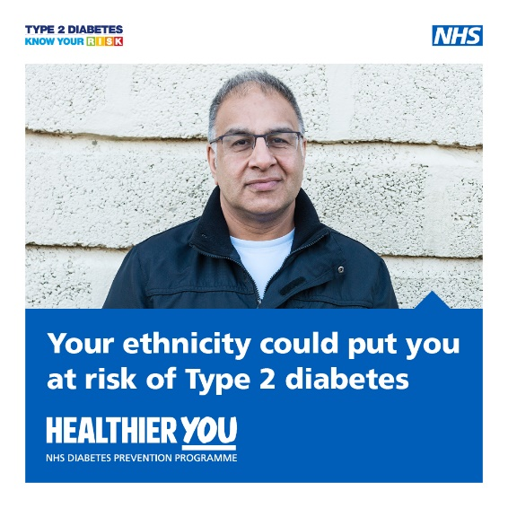
14.11.22 | Finding out your risk of Type 2 diabetes only takes a few minutes. It could be the most important thing you do today....  By completing this tool, you may be eligible for the Healthier You NHS Diabetes Prevention Programme.  Visit riskscore.diabetes.org.uk  #Diabetes  #WorldDiabetesDay | 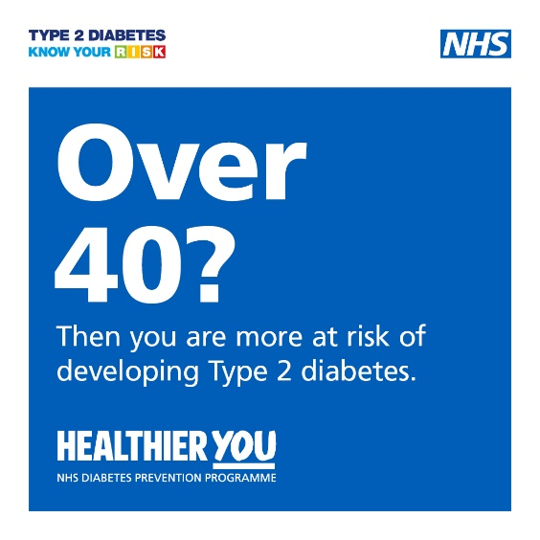
14.11.22 | Type 2 diabetes is two to four times more likely in people of South Asian descent and Black Caribbean or Black African descent.  That’s why it’s really important that you find out if you are at risk.  Visit riskscore.diabetes.org.uk  #Diabetes  #WorldDiabetesDay #RewriteTheStory | 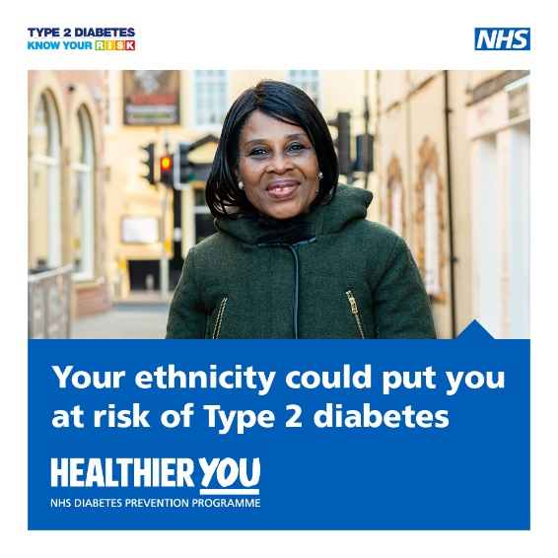
14.11.22 | Finding out your risk of Type 2 diabetes only takes a few minutes. It could be the most important thing you do today....  By completing this tool, you may be eligible for the Healthier You NHS Diabetes Prevention Programme.  Visit riskscore.diabetes.org.uk  #Diabetes  #WorldDiabetesDay | 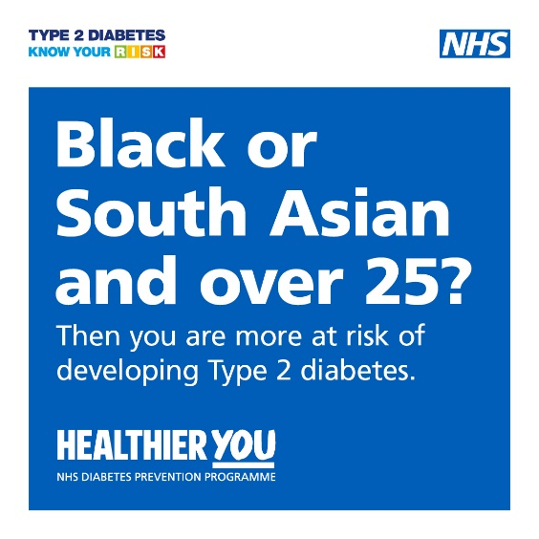
14.11.22 | Type 2 diabetes is two to four times more likely in people of South Asian descent and Black Caribbean or Black African descent.  That’s why it’s really important that you find out if you are at risk.  Visit riskscore.diabetes.org.uk  #Diabetes  #WorldDiabetesDay #RewriteTheStory | 

