Date | Caption | Graphic
31/01/23 | #TimeToTalk Day is on 2 Feb.  How will you have your conversation about mental health?  Help is out there for those experiencing a #mentalhealth crisis www.nhs.uk/mental-health  #TimeToTalk | 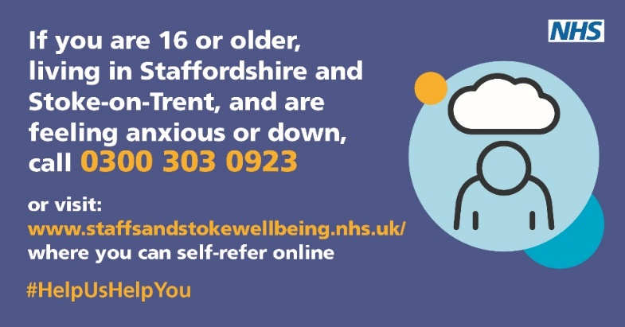
01/02/23 | It’s Time to Talk Day on Thursday 2 February 2023: a chance for all of us to be more open about mental health – to talk, to listen, to change lives.  If you need help with your mental health, you can refer yourself, or your GP can refer you.  Let us help you get your feet back on the ground.  Go to nhs.uk/help  #HelpUsHelpYou #TimeToTalk #MentalHealth | 
02/02/23 | It’s ok to ask for help.  If you think you need help or notice you’re starting to feel differently, talking to someone is often the first step to feeling better.  To learn more about where to get help visit –  www.nhs.uk/mental-health  #TimeToTalk #MentalHealth | 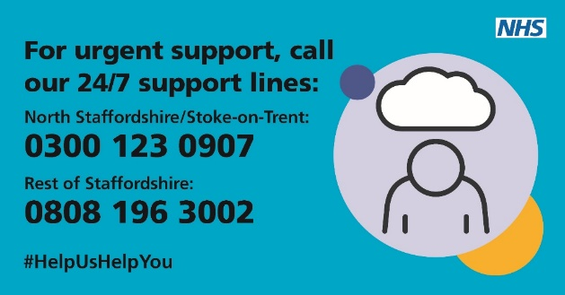
02/02/23 | It’s #TimeToTalk Day today.  The NHS is here to help. Feelings of anxiety and depression can affect us all.  If you need help with your mental health, you can refer yourself, or your GP can refer you.  Let us help you get your feet back on the ground.  Go to nhs.uk/help  #HelpUsHelpYou #TimeToTalk #MentalHealth | 
Time To Talk Day – Social Copy

