Bank Holiday – Coronation Toolkit
All assets are available here

Topic | Copy | Image
New CORONATION - 111 | In need of medical advice over the Coronation weekend? Call 111 for non-emergency healthcare support. Don't hesitate to reach out for help when you need it! | 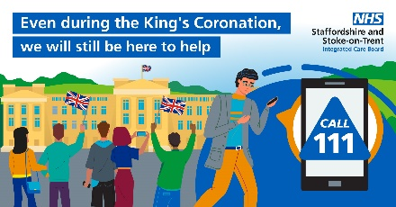
New CORONATION - Pharmacy | Pharmacists are here to help! Ensure you order repeat prescriptions in good time, and if you need medication advice over the Coronation weekend, Search 'find a pharmacy NHS' to find an open pharmacy near you. | 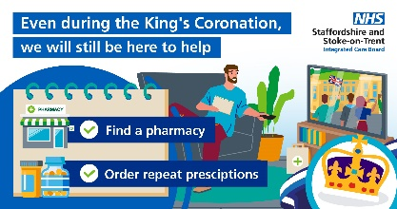
Primary Care | If you have a health concern over the Coronation bank holiday, please contact your general practice team as normal. When closed, visit NHS 111 online or call for any urgent health concerns.  Visit the NHS website to learn more about symptoms to look out for, when to seek medical help and what to do in an emergency. ➡️ http://nhs.uk/ | 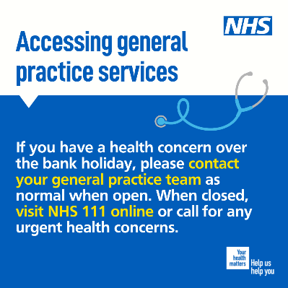
Pharmacy | Your local pharmacist can help with minor health problems, such as aches and pains, allergies, sore throats and colds, stomach problems and skin conditions.  Search “find a pharmacy NHS” to find an open pharmacy near you. | 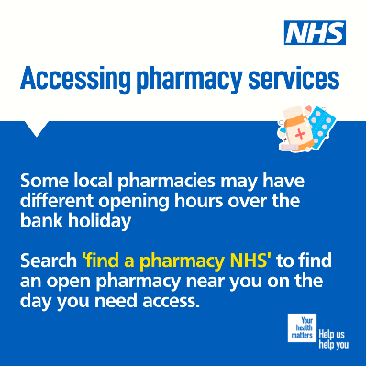
Pharmacy | Order your repeat prescriptions now! Making sure you have enough of the right medication is an essential part of maintaining your own health and relieving the strain on health services.  Search “find a pharmacy NHS” to find an open pharmacy near you. | 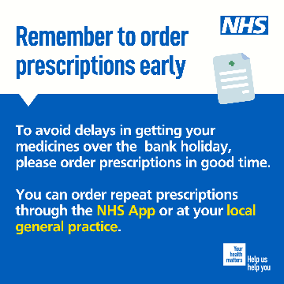
111 | If you’ve got an urgent, but not life-threatening, medical need, visit www.111.nhs.uk for immediate advice and support.  Call 111 if you can’t access 111 online.  #Think111First | 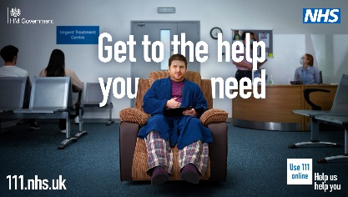
111 | Feeling unwell and not sure what to do?  Answer questions about your main symptoms to find out what to do and, if needed, where to go. Visit www.111.nhs.uk or call 111  #Think111First | 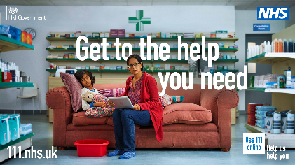
Mental Health | Are you feeling lonely this Bank Holiday?  Loneliness has no common cause. Sometimes it can be triggered by a life event or change, or it may not be triggered by anything at all.  Find out more about the steps you can take to help yourself and those around you at https://www.nhs.uk/every-mind-matters/lifes-challenges/loneliness | 