- Service Specifications

Service Specification No. | 01
Service | Tier 3 Community Ophthalmology Service
Commissioner Lead
Provider Lead
Period | 1st April 2023 – 31st March 2024
Date of Review
1. Population Needs
  - National/local context and evidence base

The number of people in the UK with sight loss is set to increase dramatically in the future due to people living longer and also a growing incidence in key underlying causes of sight loss such as obesity and diabetes. Almost two million people in the UK are living with sight loss and it is predicted that by 2020, the number of people with sight loss will increase to over 2,250,000. By 2050 the numbers of people with sight loss in the UK will double to nearly four million. Age related macular degeneration is by far the leading cause of blindness in adults. However, other significant causes of sight loss are glaucoma, cataracts and diabetic retinopathy (Royal College of Ophthalmologists).

A number of locally agreed pathways are in place across the area of North Staffordshire and Stoke on Trent and are delivered within the community by Community Optometrists with a Special Interest who have been accredited to deliver services over a number of years. The pathways currently commissioned are Paediatric Shared Care, Minor eye conditions, Adnexal, Glaucoma Referral Refinement (GRR) and glaucoma monitoring. In addition to these pathways and because of growing demand within the Local Health Economy for Ophthalmological care,

Commissioners are looking to procure a Community Eye Service that is Consultant led and that encompasses a Multi-Disciplinary Team (MDT) approach to ensure that patients are seen in the most appropriate place for their condition, by the most appropriate person and as close to home as possible.

The service will be pivotal to the achievement of reduced waiting times by offering more community based services to patients, therefore reducing demand for secondary care and releasing that capacity for those patients with more complex and urgent needs. The service will also benefit patients by delivering a more efficient and effective care pathway and the provision of alternative treatment settings will support the reduction in demand for secondary care where appropriate.

2. Outcomes
2.1 NHS Outcomes Framework Domains & Indicators

Domain 1 | Preventing people from dying prematurely
Domain 2 | Enhancing quality of life for people with long-term conditions | √
Domain 3 | Helping people to recover from episodes of ill-health or following injury | √
Domain 4 | Ensuring people have a positive experience of care | √
Domain 5 | Treating and caring for people in safe environment and protecting them from avoidable harm

2.2 Local defined outcomes
- Early diagnosis and treatment for patients with common ophthalmology/ eye conditions.
- To reduce physical and associated disabilities that are caused by ophthalmology/ eye conditions.
- To provide a service that is patient centred and improves the patient experience.
- To improve patient access and equity of provision.
- To provide a quality service that is clinically safe.
- Patients are seen and treated in the most appropriate setting
- Rapid access into the service, as well as rapid access to diagnostics when required
- Streamline patient pathway and encourage integration with optometrists, orthoptists and secondary care providers
- All service users are seen and treated within the 18 week RTT pathway
- New to follow up ratio must not exceed 1:2.9

3. Scope
3.1 Aims and objectives of service
The service shall deliver a consultant-led community one-stop(where clinically appropriate) ophthalmology service with the overall aim of providing timely assessment of the needs of a patient presenting with a eye conditions who would otherwise present in a secondary care service.

The overall aim and objectives are to:

- Enhance the patient pathway by effectively managing patients within the community;
- To improve access to the most specialist clinical expertise for various eye conditions;
- Achieve improved outcomes for patients;
- To triage and signpost appropriately all referrals entering the service e.g. referral to secondary care for red flags;
- To provide a service that is multi-disciplinary, patient focused and improves the patient experience;
- To provide access to high quality, safe care that gives timely advice, appropriate support, assessment, diagnosis and treatment for patients according to their individual need;
- To ensure the service is delivered in line with current policy, learning and best evidence, providing appropriate governance and management;
- To develop common pathways of care ensuring there is no unnecessary duplication, and to promote the integration and coordination of services across primary care and accredited secondary care providers;
- To deliver a service that demonstrates equity of access;
- To provide care closer to home where appropriate;
- The service shall provide a seamless service from referral to diagnosis and treatment avoiding unnecessary transfers of care and additional appointments;

3.2 Service description/care pathway
The service will treat patients suffering from a range of eye conditions and is intended to be a triage and treat clinic to minimise the need for numerous follow ups. Conditions to potentially be seen within the clinic are set out below:

Eyelids/Orbit  Cysts  Dacrocystitis  Ptosis  Entropian  Ectropian  Dermatochalasis  Eczema  Concretions  Epiphoria | Conjunctiva, Sclera  Cysts  Inflammation  Pterygium  Anterior Chamber  Anterior Uveitis  Vitreous  Opacities
Retina  Pigmented abnormalities  Disc abnormality  Retinoschisis  Epiretinal membrane | Cornea  Endothelial abnormality  Dystrophy  Keratitis  Minor Ops  Chalazion  Iris  Pupil abnormalities  Posterior synechiae
Follow ups

OHT diagnosis
OHT on treatment
Glaucoma

The Provider is expected to develop a shared care pathway for the management of stable glaucoma patients with local community optometrists. All patients who meet the inclusion criteria will be referred to the service for triage / treatment / onward referral where necessary.

Referrals will be received and triaged into the correct pathways by the provider. The triage will form part of the patient’s pathway and will not be funded separately by Commissioners.

Minimum equipment is expected to include:

- Humphrey visual field machine (or equivalent threshold visual field screener) and printer
- Slit lamp
- Applanation tonometer
- Ophthalmoscope
- Amsler charts
- Epilation equipment
- Diagnostic drugs (mydriatics, stains, local anaesthetics, etc)
- Volk lens
- Tonometer

The service should be based within the community and it is expected that the provider will work to ensure that a wide range of community options are available by continuing to work with, accredit and support the current COSIs and GPSIs.

The service is aimed at GP and Optometrist referrals which shall arrive via the Choose and Book system and follow the pathway as detailed below:

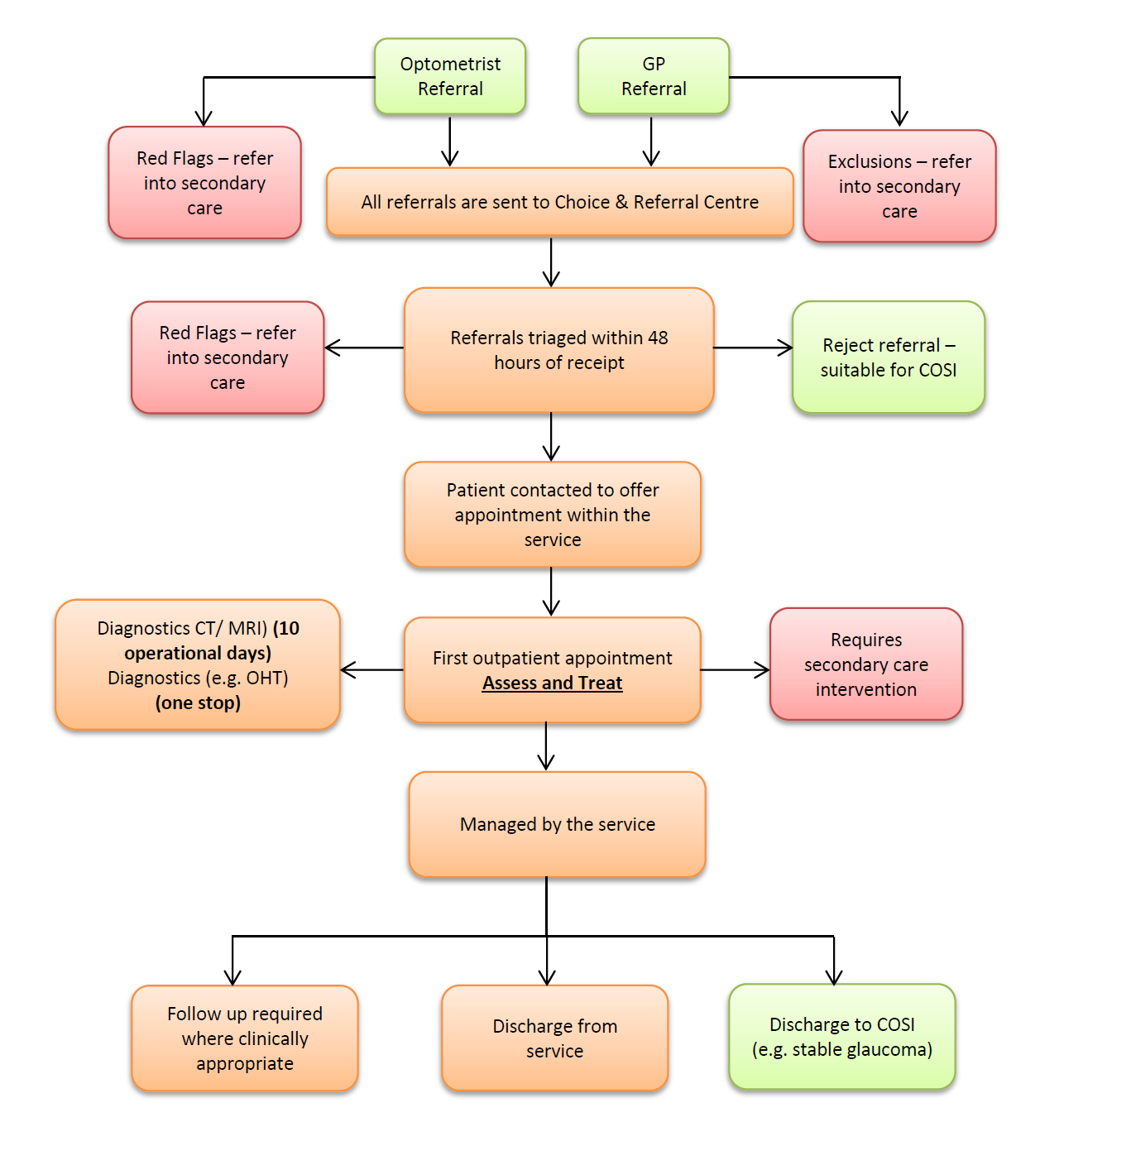
DNA (Access Policy)
- A patient DNAs when they do not attend a planned appointment, (face to face or telephone call) and provide no advanced warning or arrive late to an appointment and are not able to be seen.
- Unable to Attend Appointment (UTA) Where a patient provides prior notice that they are unable to attend an appointment, they are recorded as being ‘Unable to Attend’. This is also known as a cancellation.
- The provider shall use a risk and needs based approach in its response to DNAs which includes assessment in line with Adult Safeguarding Policies
- Where a patient has failed to attend an appointment they will be offered one further opportunity to attend before the provider returns the referral back to the referring GP
- Where a patient DNA an appointment there will be no payment made to the provider

Discharge Criteria and Planning

Discharge Criteria:-
- In regard to DNA - Discharging the patient must not be contrary to the patient’s best clinical interests. (or there is no prior knowledge of the patient having a lack of capacity to refuse or decline treatment)
- The Service User wishes to be discharged from the service.
- The Service User requires a surgical intervention and has been treated by the Provider (e.g. Diagnostic tests)
- The Service User is been sent to another service (Community Physiotherapy, Mental Health, Continence Service, etc.)
- The Service User’s treatment plan, goals or objectives have been achieved.
- The Service User does not comply with the treatment recommendations.
- The Service User does not attend for requested investigations.

Discharge Planning:-
- The Service User has received knowledge of how to self-manage their condition through treatment and health promotion advice has been provided.
- Report is compiled and sent to the referring GP within operational 3 days
- transmission of both clinic letters and discharge summaries to general practices must be via direct electronic transmission, not via email
- Relevant advice and literature are given to Service Users /carers/relatives
- Service Users shall be discharged with a detailed care plan for continued care and advice for Primary Care that will also support healthy lifestyle management and intervention

All Service Users being referred on to secondary care shall be offered a choice of Provider via the Commissioner’s Choice and Referral Centre. The Provider shall be expected to have sufficient confidence with secondary care providers that direct listing for a range of inpatient procedures occurs.

3.3 Population covered

This service will be routinely provided to patients registered under a North Staffordshire or Stoke on Trent GP.

3.4 Location

The service should be located within the geographical boundaries of NHS Stoke on Trent and NHS North Staffordshire GP localities. The provider should ensure that all facilities used are fully compliant with DDA regulations.

The service provider is required to identify the appropriate levels of capacity and setting to allow for communication, consultation and booking in / reception area.

Sites should have adequate patient parking and access be compliant with Disability and Discrimination Act 2005.

The Service Provider must ensure that the service is equitable and accessible to the local population and new comers.

Locations to demonstrate accessibility to main road networks and public transport for those patients where private transport is not an option. To be communicated as necessary and ensure information about physical access available accordingly.

3.5 Days and hours of operation

The Provider shall ensure that services are delivered across 7 days of the week offering choice of appointments in the evenings and or at the weekends. The Provider shall be flexible in its approach to 7 day working.

3.6 Interdependence with other services/providers
The service will rely on building activity to the planned capacity levels, and as such will be dependent on referring clinicians being aware of the service and the appropriate patients to be referred into the service. Commissioners will market the service sufficiently to build this knowledge and awareness within the local health economy. Aggressive marketing of the service that has the potential to increase demand will not be permitted and any marketing materials must be run past the commissioning lead from the ICB for approval prior to release.

The approach to delivery should be based on shared care i.e. communication between all clinicians looking after patients, with the appropriate level of staff carrying out appropriate interventions, and structured around the patient journey.

The service provider will be expected to work alongside a number of other services and ensure patients move smoothly through the pathway by facilitating appropriate partnership working and onward referrals with:

- Patients and carers
- Voluntary sector
- Community Optometrists
- General Practitioners
- Practice Nurses
- Social Services
- ICB Commissioners
- ICB clinical leads
- Secondary care providers and Consultants

Whole System Relationships

The service will link with the patient’s own GP and the referring optician, and accurate, timely communication will be expected between providers, GPs and the referring Optician. Similar communication will be maintained with the patient, and each patient treated by the service will be informed at each stage of what will happen during the treatment pathway. The provider will interface seamlessly with all other services which would offer benefits to the patient.

Sub-contracting will not be permitted as part of this contract unless explicitly agreed with Commissioners.

3.7 Any acceptance and exclusion criteria and thresholds

Referral Criteria
Referral thresholds for the Community Ophthalmology Service are that the service user must be/ possess:
- Routine GP or Community Optometrist referrals only
- Age 18 years and over
- Service uses must be registered with a North Staffordshire or Stoke on Trent GP
- Have an eye related condition that the Provider has deemed suitable to treat in the community (see above conditions 3.2)
- Complex presentation of a condition that may require further investigation

Accessibility/ Acceptability
- Referrals will arrive from the Choose and Book system;
- Triage of all referrals within 48 hours of receipt;
- GP/ Community Optometrist referral to first Service User appointment:-
15 operational days, maximum
- Diagnostic tests: - as part of the first appointment e.g. OHT
- Other diagnostic tests (e.g. CT/ MRI) shall be requested and reported back to the Provider within 10 operational days.
- If referral to secondary care is deemed appropriate at triage then the referral should be sent back to the Choice and Referral Centre within 24 hours
- If onward referral is deemed appropriate after being seen within the service, then the referral should be sent back to the Choice and Referral Centre 2 operational days

Exclusion Criteria
The service is not available to:

- Paediatrics - Patients under the age of 18 years at the time of referral
- Patients not registered with a North Staffordshire or Stoke on Trent GP practice
- Patients who require emergency treatment
- Patients re-referred with post-operative or post traumatic complications
- Patients who require a second surgical opinion
- 2 week cancer referrals
- Diabetic retinopathy screening
- Suspected glaucoma patients requiring referral refinement
- Wet AMD (Patients requiring treatment and assessment for Wet AMD will be offered a choice of providers that are commissioned by the ICB).

It is expected that the first line treatment and management of the following conditions should be undertaken by community optometrists in the first instance.
- Trichasis
- Pinguecula
- Meiboniam gland dysfunction
- Blepharitis
- Allergies
- Dry AMD
- Flasher and Floaters
- Posterior vitreous detachment
- Abrasion
- Recurrent Erosion Syndrome
- Dry Eye

The Provider will be expected to deliver the service in line with the ICBs Excluded and Restricted Policy.

The service will assess all referrals against the list of agreed procedures and the exclusion criteria prior to accepting patients for treatment and patients who do not have a condition as listed within this service specification are not covered by the scope of this service.

Response Time and Prioritisation

- Referrals will arrive from the Choose and Book system;
- Triage of all referrals within 48 hours of receipt;
- GP referral to first Service User appointment:- 15 operational days maximum
- Diagnostic tests: - as part of the first appointment e.g. OHT
- Other diagnostic tests (e.g. CT/ MRI) shall be requested and reported back to the Provider within 10 operational days.
- If referral to secondary care is deemed appropriate at triage then the referral should be sent back to the Choice and Referral Centre within 24 hours
- If onward referral is deemed appropriate after being seen within the service, then the referral should be sent back to the Choice and Referral Centre 2 operational days

  - IM&T and Information Governance

The Provider shall comply with the Information Governance Framework for Health and Social Care and ensure that information relating to patients is safeguarded and taken account of in relation to:

- Patient confidentiality
- Caldicott Guardian Principles
- Consent to treatment and use of information
- NHS Standards for Information Security

The provider shall have robust and effective systems in place for handling information securely and confidentially, with appropriate information sharing agreements in place with all partner organisations. The Provider shall achieve and maintain a minimum of level 2 compliance of each component of the Information Governance Toolkit which will be submitted annually.

The Provider shall demonstrate compliance with relevant legal and regulatory standards regarding data protection and information governance and ensure that all staff contracted by them and who access NHS Information, documents, IT systems and networks are properly trained and authorised to do so.

The service will retain and back-up clinical data in accordance with DoH guidelines.

The provider must have an N3 connection.

3.9 Medicines Management

Non PbR medicines for Wet AMD are excluded from this provision.

The Provider shall abide by any commissioning policies or positioning statements provided by commissioners.

The Provider shall conform and adhere where appropriate to NICE guidance.

The Provider shall request , prior approval for any high cost excluded PbR drugs via blueteq at https://www.blueteq-server.co.uk/NSS-HCD/default.htm - login can be achieved via NSS-HCD@blueteq.co.uk

The Provider shall ensure that all clinicians and health care staff involved in enabling access to medicines are aware of the requirements of this section of the specification and abide by its terms.

The Provider shall develop and maintain organisational policies and procedures that reflect the standards of care and patient safety that might reasonably be expected from such a provider and ensure that policies and procedures are effectively communicated throughout the organisation. All policies and procedures must comply with the relevant regulations with regards to medicines including the Medicines Act 1968, Human Medicines Regulation 2012, the Misuse of Drugs Act 1971 (as amended), the Misuse of Drugs Regulations 2001 (as amended), the Misuse of Drugs (Safe Custody) Regulations (as amended), the Health Act 2006 and the Mental Health Act 2007.

Prescribing of any medication will be required for 28 days (or such shorter period for a full course of medication as appropriate) post discharge and will be provided as part of the service and will be included in the price. Any recommendation for continued prescribing in primary care must adhere to local ICB’s formularies and guidelines.

The provider shall ensure that it has robust and auditable systems in place for procurement, storage, dispensing, prescribing and disposal of medicines. Electronic record keeping will be an integral component of these systems and it should be possible for records of medicines supplies and prescribing to be shared electronically with electronic medical systems in General Practice. Where electronic record keeping arrangements do not comply with Controlled Drugs Regulations, paper recording systems must be in place.

The service shall ensure that prescription forms (whether single sheets or pads) are stored securely and that robust and auditable systems are in place for use of prescription forms ensuring that each form can be accounted for.

All staff involved in supply or prescribing of medicines must have the relevant qualification to perform that role.

All medicines management activities should be covered by Standard Operating Procedures that meet current legislation, licensing and good practice.

The provider shall have appropriate written procedures in place for dealing with patient safety incidents and near misses involving medicines. Reporting of these incidents shall comply with both local and national systems. The provider shall undertake audits of reported incidents at intervals specified by the Commissioner with audit reports submitted to the Commissioner.

Commissioners will not support the use of unlicensed drugs where an appropriate licensed alternative is available. The provider shall conform and adhere where appropriate to a NICE HTA/TAG and use NICE initiations and continuation forms via the Blueteq system https://www.blueteq-server.co.uk/NSS-HCD/default.htm

3.10 Workforce and Accreditation

A consultant-led service is a service where a consultant retains overall clinical responsibility for the service, care professional team or treatment.

GPs and Optometrists working independently within the service will need to meet the standards outlined in the Accreditation Process and to achieve against the competencies outlined to become a GP with a Special Interest in Ophthalmology (GPSI) or a Community Optometrist with a Special Interest (COSI).

The Accreditation period will be for three years with an annual review. It is the provider’s responsibility to ensure they meet the standards outlined in the Service Specification in order to become Accredited Practitioners.

All staff providing the service must provide evidence to demonstrate their respective experience and competencies required.

- The Provider shall be responsible for ensuring that (where relevant) their clinical and / or non-clinical staff:
- Are up to date with all statutory mandatory training as set out by the Provider
- Have relevant professional registration and enhanced Criminal Record and Barring checks undertaken prior to seeing patients alone
- Have maintained relevant professional registration whilst delivering services on behalf of the Provider. The Provider is required to conduct frequent registration audits to ensure compliance
- Have the appropriate Medical Indemnity Insurance and that their conduct is in line with the relevant terms and conditions set out in insurance as to not render that insurance invalid
- Undertake education events on topics to be agreed with the commissioner

The service shall be staffed by appropriately qualified health care professionals in sufficient numbers to deliver the needs of the service. All staff should meet the required clinical accreditation standards and competencies for delivery.

4. Applicable Service Standards
4.1 Applicable national standards (eg NICE)

Key reference points for Providers will include:

- NICE Guidelines
- The Royal College of Ophthalmologists
- The College of Optometrists

Crucially, services will ensure that the recommendations set within the Francis report as listed below are met:

- Independent Inquiry Into Care Provided by Mid Staffordshire NHS Foundation Trust January 2005-March 2005 volumes 1 and 2 (Francis,R.2010)
- Report of the Mid Staffordshire NHS Foundation Trust Inquiry (Francis, R. 2013)

Providers will be expected to comply against all nationally mandated standards and the provider is also expected to deliver care in accordance with all nationally acknowledged agencies including the following as appropriate:

- Guidelines for the Management of Open Angle Glaucoma and Ocular Hypertension’ published by the Royal College of Ophthalmologists in 2004.
- Royal College of Ophthalmologists Cataract Surgery Guidelines (2001)
- Healthcare Commission (2006) Standards for Better Health 2006/7
- National Patient Safety Agency (2005) Building a Memory – preventing harm, reducing risk and improving patient safety
- National Minimal Standards for Independent Health Care (if relevant)
- Office of Public Sector Information – Freedom of information Act (2000), Human Rights Act (1998), Data Protection Act (1998)
- British National Formulary – latest edition
- Any other guidelines or current national guidance

The provider of this service has an onus of responsibility to keep up to date with clinical practice and comply with new guidance as it is published. Pathways should be amended to reflect agreed new guidance after agreement with the commissioner.

4.2 Applicable standards set out in Guidance and/or issued by a competent body (eg Royal Colleges)

As section 4.1

4.3 Applicable local standards

5. Applicable quality requirements and CQUIN goals
  - Applicable Quality Requirements (See Schedule 4A-C)

6. Location of Provider Premises
The Provider’s Premises are located at:

7. Individual Service User Placement
Not applicable

