SCHEDULE 2 – THE SERVICES

- Service Specifications

Service Specification No. | AQP_VAS_22/23
Service | Non-Scalpel & Scalpel Vasectomy (Male Sterilisation)
Commissioner Lead
Provider Lead
Period | 01/01/2022– 31/03/2023
Date of Review | As and when required by either Commissioner or Provider

POPULATION NEEDS
- Population Needs
  - National/local context and evidence base
    - Sterilisation has become increasingly popular since the late 1960’s. Discussion of sterilisation is a routine part of contraceptive advice offered by health professionals. Vasectomy is indicated when a man wishes to make a permanent and irreversible decision that they should never subsequently conceive a child of their own. It is a voluntary act with the request coming from the man wishing to be rendered infertile and the procedure may be offered irrespective of age or marital status. (Reference: Male and Female Sterilisation, Evidence-based clinical guideline number 4, Royal College of Obstetricians and Gynaecologists (RCOG), 2004).

    - The Information Centre (2009) in their document NHS Contraceptive Services England 2008/09 advise that the number of men attending clinics accounts for only a small proportion of the total attendances, but this number has risen from approximately 79,000 in 1997/98 to about 140,000 in 2008/09. Data from HES suggest that approximately 40,800 vasectomies were performed in England in 1997/98 and this has declined steadily each year, falling to 23,600 in 2007/08.

    - Sterilisation can be an empowering decision for the right person at the right time however its intended permanency means that the onus is on the health care practitioners involved to ensure that the service user has all the information required in order to make an informed choice which is also available in other languages if required. In England requests for reversal of vasectomy in 1993 were 1.4 thousand reducing to 0.6 thousand in 2002 (Department of Health (DOH) statistics).

    - Providers shall have local strategies in place for providing information to both clients and professionals on the choices available within the service and on access to the service.

    - Vasectomy is a procedure that stops sperm from travelling to the testis through the cutting of the vas. It is recommended by the RCOG as the preferred method of sterilisation.

    - Vasectomy is a minor procedure that takes around 15 minutes and is very safe in competent hands.
    - The failure rate of vasectomy is very low (1 in 2000 after clearance has been given). Vasectomy carries a lower failure rate in terms of post-procedure pregnancies and there is less risk related to the procedure than female sterilisation.

OUTCOMES
- Outcomes
  - NHS Outcomes Framework Domains & Indicators
Domain 1 | Preventing people from dying prematurely
Domain 2 | Enhancing quality of life for people with long-term conditions
Domain 3 | Helping people to recover from episodes of ill-health or following injury
Domain 4 | Ensuring people have a positive experience of care
Domain 5 | Treating and caring for people in safe environment and protecting them from avoidable harm

  - Local Defined Outcomes
    - Service user shall receive an effective quality vasectomy procedure with low complications rates in line with Royal College of Gynaecologists and Obstetricians in a community location of their choice
    - Achieve value for money through reduced costs and increased quality outcomes
    - To ensure consistent and continuous care between health professionals, and effective and efficient communication
    - Development of a patient pathway within a community-based setting
    - 95% of Service Users shall be seen within thirty (30) minutes of their appointment time
    - 95% of referrals shall undergo an initial triage assessment within one (1) week of receipt
    - 95% of Service Users shall be offered a Pre-Procedure Appointment/Consultation, which shall take place within four (4) weeks of the date the referral was received by the Provider
    - 95% of Service Users shall be offered an appointment for the procedure no earlier than two (2) weeks and usually no later than six (6) weeks after the pre-operative assessment/consultation

SCOPE
- Scope
  - Aims and Objectives of Service
    - The Provider shall provide a high quality and safe no-scalpel & scalpel technique vasectomy under local anaesthetic, in accordance with the Royal College of Obstetricians and Gynaecologist guidelines, (RCOG), in a primary care setting to all adult males who request it, are of sound mind, not acting under external duress.
    - The main aims of the Service are:
- To provide service users with a high-quality vasectomy service within a Primary Care setting which offers counselling and post-operative treatment in a setting close to home
- Improve service users experience
- Provide a service which is clinically effective and safe
- Provide a service in line with NICE guidelines and other relevant advisory bodies, promoting best practice and in line with the Commissioners requirement and approval
- To provide services that comply with accepted best practice, relevant accreditation processes, relevant guidelines in clinical practice and robust governance arrangements.
- To provide a complete holistic service user focused care package, including pre- and post-operative care, information, advice, and counselling
- To provide an opportunity for men’s Health Promotion
- To ensure consistent and continuous care between health professionals, and effective and efficient communication.
- To improve access and convenience for patients
- To improve patient choice

  - Service Description / Care Pathway
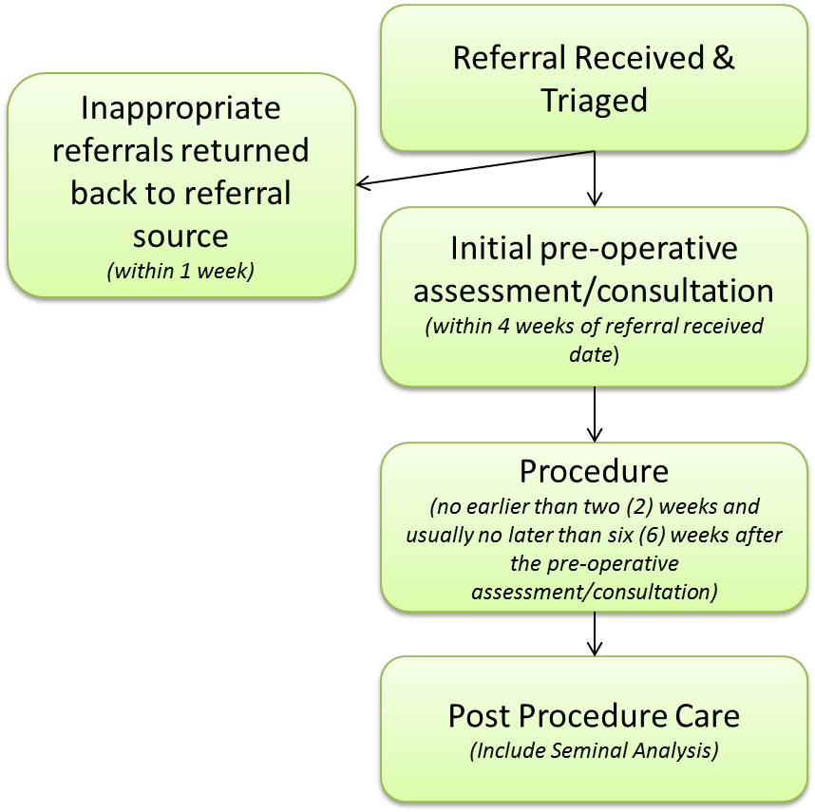

  - Access to the Service
    - The Provider shall be listed on the Choose and Book system and accept all clinically appropriate referrals.
    - The Provider shall accept a standard referral form, which will be available through local referral facilitation tools / websites, which will include specific patient, focused health care questions that function as an initial triage system. Referrers shall indicate why sterilisation is required.
    - The Provider shall return referrals which are not appropriate for a community service to the source of referral within one week.
    - The Provider shall ensure that a choice of service has been given to the Service User.
    - The Provider shall run clinics which will meet the needs of Service Users; this can be outside of normal GP practice surgery hours and weekends.
    - The Provider shall ensure that the service offered is respectful and does not discriminate on grounds of age, gender re-assignment, sexuality, ethnicity or religion (for protected characteristic groups who are most likely to experience disadvantage) Services should be sensitive to the needs of clients whose first language is not English, and those with hearing, visual or other disability.
    - The Provider shall be responsible for the receipt and administration of all referrals. Service Users should be seen within half an hour of their appointment time and flow through the clinic should be without undue delay.
    - The Provider shall ensure protocols are in place for, discharging the patients from the service back to the GP, and transfer to secondary care if complications arise.
    - The Provider shall offer all Service Users a chaperone for any examination. If the offer is declined this should be recorded in the Service Users notes. If a chaperone is present a record should be made of the identity of the chaperone.
    - The Provider shall ensure that all adult males who request a vasectomy are of sound mind, not acting under external duress and who do not have any of the exclusion criteria. It should be made clear to patients that the NHS, other than in exception individual circumstances, will NOT fund reversal of the procedure. Marital breakdown change of partner or remarriage is not unusual. Such events would not be considered sufficient grounds to give an individual priority for funding a sterilisation reversal. Vasectomy reversals have only been agreed to date when patients have clearly demonstrated that the vasectomy procedure was undertaken under duress or inadequate counselling. The death of a child although rare and tragic would not be considered sufficient grounds for a reversal and should be discussed during the pre-vasectomy counselling within worst – case scenarios.
  - Support, Advice and Assessment Appointment
    - The Provider shall ensure that written information about the procedure and follow up care is given to the Service User. Pre-operative individualised assessment must include a process of counselling and consent. It shall also include a full range of information about access to other long-term reversible methods of contraception. Service Users should be informed that reversal operations or intracytoplasmic sperm injections are rarely available on the NHS as it is considered a low priority procedure and will only be considered in exceptional cases. Information should be provided on the advantages, disadvantages and relative failure rates of each method.
    - The Provider shall ensure that the counselling, information exchange, history and examination have been completed and be satisfied that the patient does not suffer from concurrent conditions which may require an additional or alternative procedure or precaution. Counselling will also consider cultural, religious, psychosocial, psychosexual, and other psychological issues in relation to protected characteristic groups some of which may have implications beyond fertility. The Provider shall concentrate on factual information and avoid persuasion or any act that may be deemed coercive however clear the advantage of their recommended option appears to be. The provider shall where possible obtain agreement for the procedure to be undertaken from both the service user and partner (where applicable). However, it is not a legal requirement to get a partner's permission.
    - The Provider shall ensure Service Users are reassured that there is no increase in testicular cancer or heart disease associated with vasectomy. The association of an increased risk of prostate cancer is at present likely to be considered to be non-causative. Service Users shall be informed of the risk of chronic testicular pain after vasectomy.
    - Additional consideration will be taken when counselling service users that.
- Are under the age of 30 years
- Have few or no children already (few usually relates to two or fewer)
- Are not in a relationship
- Not in a mutually faithful relationship or in a crisis relationship
- May be making the decision as a reaction to a loss of a relationship
- Who may be at risk of coercion by their partner, family or health or social welfare professional
- Information should be provided on the advantages, disadvantages and relative failure rates of each method.

    - The provider will not be entitled to any payment tariff whereby a service user does not attend (DNA) the Pre-Procedure Appointment/Consultation.
    - In the event that a service user attends for the Pre-Procedure Appointment/Consultation, and fails to attend any further appointment, or expresses the desire to withdraw from the procedure, the Provider will be entitled to the Pre-Procedure Appointment/Consultation tariff only.
  - Response time, detail and prioritisation
    - The Provider shall complete an initial triage assessment of the referral to ensure the service user appears suitable for a community vasectomy service within one week of receipt of the referral. Referrals not appropriate for a community service to be returned to source of referral within one week.
    - The Provider shall offer an appointment within four weeks of receipt of the referral
    - The Provider shall offer an appointment for the procedure no earlier than 2 weeks and usually no later than 6 weeks after the pre-operative assessment to ensure a cooling off period is allowed
    - The service provider shall not cancel appointments except in exceptional circumstances. Where exceptional circumstances do occur, the provider shall inform the Commissioners in writing within 7 days of the event.
  - Vasectomy Procedure
    - All vasectomies shall be performed under local anaesthetic except when technical considerations dictate otherwise, a no scalpel approach should be used to identify the vas deferens as this results in a lower rate of early complications. Clinicians who are working towards competency in the no scalpel procedure shall complete training/accreditation within 2 years of applying for the service.
    - The Provider shall use single use disposable equipment will be used wherever possible. The clinic environment shall be suitable for delivery of an invasive procedure. Division of the vas deferens on its own is not an acceptable technique because of its failure rate. It should be accompanied by fascial interposition or diathermy. Clips will not be used for occluding the vas, as failure rates are unacceptably high excised portions of the vas deferens will only be sent to histological examination if there is any doubt about their identity.
    - The clinic environment shall be suitable for delivery of an invasive procedure.
    - The Provider shall offer a one stop approach only if the Service User requests it and it is deemed appropriate following a comprehensive telephone consultation by the surgeon. A two-week cooling off period between pre-operative information / assessment and the procedure must still be enforced.
    - In order to maintain continuity of service to service users, existing service providers performing scalpel only procedures are allowed a maximum of 6 months from the date of service commencement under this Service Specification to retrain to perform the scalpel / non- scalpel method. If the Provider is unable to find a suitable training within this timeframe, he/she must contact the named Co-ordinating Commissioner as soon as possible.
    - If the Provider is trained in performing Vasectomy procedures but has no prior experience, then they will be supervised for ten operating sessions or forty procedures. GPs with relevant prior surgical experience will perform eight supervised procedures. The GP who performs or supervises a trainee performing a vasectomy will take responsibility for the procedure even when discussion, examination and consent were undertaken by other Healthcare Professionals.
  - Post Procedure Care
    - The Provider shall ensure that post vasectomy care including emergency contact numbers (when and who to contact), pain relief, wound care, resuming normal activities including sexual intercourse, contraception prior to clearance and seminal analysis is given to all Service Users.
    - The Provider shall ensure seminal analysis is carried out at a recognised laboratory and funded by The Provider. Service Users shall be advised to continue to use effective contraception until azoospermia has been confirmed. Irrigation of the vas deferens during vasectomy does not reduce failure rates or time to clearance.
    - The Provider shall advise Service Users on how to comply with seminal analysis and supply all necessary equipment in advance of the 16- and 20-week target.
    - The Provider will inform patients that they will require at least one clear seminal analysis results at 3 months post vasectomy before the vasectomy is considered successful, in line with British Association No Scalpel Vasectomy recommendations. In a small minority of men, non-motile sperm persist after vasectomy. In such cases ‘special clearance’ to stop contraception may be given when fewer than 10,000/ml non motile sperm are found in a fresh specimen examined at least seven months after vasectomy, as no pregnancies have yet been reported under these circumstances (Recommendation 44, Reference: Male and Female Sterilisation, Evidence-based clinical guideline number 4, Royal College of Obstetricians and Gynaecologists, 2004)
    - The Provider shall forward seminal analysis results to the Service User and their General Practitioner
    - The Provider shall maintain a register of failed vasectomies and a register of post-operative complications
  - Confidentiality
    - The Service shall be, and be known to be, strictly confidential. A written Confidentiality Policy shall be prominently displayed and made available to service users. Staff should be able to demonstrate an understanding of the policy and process and be able to communicate this to Service Users using the service.
    - Confidentiality shall be maintained throughout the Service Users visit. Care should be taken to ensure that information is not shared with anyone other than the patients GP and those immediately associated with their care. In order to maintain confidentiality, no information should be sent to the Service Users home address unless the Service Users expressly wishes this.
    - The Provider shall be expected to demonstrate that the collection, storage and transfer of information to other services, including that in electronic format is secure and complies with any data protection requirements.
  - Consent
    - The Provider shall be expected to operate a policy for obtaining consent that complies in all respects with the requirements of National Minimum Standards and the Private and Voluntary Healthcare (England) Regulations 2001 and any other relevant guidelines. Interpreting services will be used where mutual communication is experienced to achieve consent. Competent consent is understood in terms of the client’s ability to understand the choices and their consequences, including the nature, purpose and possible risk of any treatment (or non-treatment). In assessing competence, the Service Provider needs to refer to the Department of Health (DOH) Reference Guide to Consent for Examination or Treatment (2001).
    - The consent form shall include a statement of indemnity which relieves the Provider of any responsibility if a pregnancy occurs because the patient fails to comply with seminal analysis
  - Population Covered
    - The Provider shall provide services to all Service Users registered with a General Practitioner in Stafford and Surrounds CCG, Cannock Chase CCG and South East Staffordshire and Seisdon Peninsular CCG for whom the Commissioners are responsible for funding healthcare services.
  - Any acceptance and exclusion criteria and thresholds
    - Referrals will be accepted from:
- GP’s
- Genito Urinary Medicine (GUM) Clinics and
- Contraception and Sexual Health (CASH)
- Any other relevant agencies/clinicians
    - Surgery should be delayed if the following conditions are present:
- Scrotal skin infection
- Active sexually transmitted disease
- Balantis
- Epididymitis
- Orchitis
    - Surgery should be undertaken with caution if the following are present:
- Previous scrotal surgery
- Hydrocele
- BMI>35
- Drug or alcohol misuse
    - Exclusion criteria:
- Anybody under the age of 18
- Self-Referral
- Lack of consent
- Varicocele
- Inguinal hernia
- Cryptorchidism
- Anticoagulant therapy
- Coagulation disorders
- Mental instability
- A history of an allergy to local anaesthetic
- A history of fainting easily
- Patient refusal of local anaesthesia
- Those deemed unsuitable for local anaesthetic
- Scrotal skin infection
- Active sexually transmitted disease
- Balanitis
- Epididymitis
- Orchitis.
    - There is no age-related exclusion, however, men under 30 years of age, particularly without children must be aware of the implications and advised that reversal of a vasectomy is considered an excluded and restricted procedure and shall only be considered in exceptional cases.
  - Response time, details and prioritisation
    - The Provider shall offer an appointment within four weeks of receipt of the referral
    - The Provider shall offer an appointment for the procedure no earlier than 2 weeks and usually no later than 6 weeks after the pre-operative assessment to ensure a cooling off period is allowed
    - The Provider shall complete an initial triage assessment of the referral to ensure the patient appears suitable for a community vasectomy service within one week of receipt of the referral.
    - Referrals not appropriate for a community service to be returned to source of referral within one week.
    - The Provider shall not cancel appointments except in exceptional circumstances. Where exceptional circumstances do occur, the provider will inform the Commissioners in writing within 7 calendar days of the event.
  - Discharge Criteria
    - Discharge criteria will be in accordance with agreed care pathways.
  - Discharge Procedure (Care Transfer)
    - Information shall be given to the patient on discharge, which explains the likely course of recovery, including pain and bleeding and with sufficient information to allow another practitioner elsewhere to deal with any complications. Symptoms indicating deviations from the normal course of recovery must be explained and the client advised how and when to seek medical help. Clients should have a list of those complications that require urgent medical consultation and should be given a 24-hour telephone helpline number to ring if they have concerns.
    - Urgent clinical assessment and emergency admission must be available if necessary. This should be supported by written information, which must be available in languages &formats appropriate to clients using the service. In most cases the local NHS Hospital Trust will deal with emergency readmissions.
    - Staff should be secured to stay beyond their contractual hours, where necessary, and this must be incorporated into the overall unit cost.
  - Promotion and support of self-care
    - The Provider will promote a culture of encouraging informed decisions regarding healthcare. The aim will be to facilitate self-care and patient / carer empowerment.
    - Signposting arrangements will be in place to direct service users to other services such as General Practitioners, Support Groups, Pharmacy, Dieticians, Physiotherapists, Citizens Advice and Social Care etc.
  - Information provided to patients and carers
    - Service Users shall receive information on what they can expect from the provider, details of appointments, chaperone facilities, confidentiality issues and contact details for the clinicians.
    - Service Users shall be informed of the vasectomy procedure, the implications, the possible benefits and risks involved.
    - Service users shall be informed of the rationale for all onward referrals ensuring patients maintain their right to make choices.
    - All information will be available in a variety of communication formats to ensure that all those with visual or hearing difficulties or whose first language is not English will not be disadvantaged. Professional interpreters will be used as appropriate.
  - Independence with other services/providers
    - Key professions that the provider will be expected to develop effective links with include:
    - General Practitioners
    - Secondary care vasectomy service provider
    - Accredited Andrology Services
    - Contraception and Sexual Health (CASH)
    - Genito-Urinary Medicine (GUM)
    - Walk in Centres
    - Interpreters and information in required format appropriate to client. i.e. Easy read, translated language, large print, braille etc.
    - Any other appropriate service.

APPLICABLE SERVICE STANDARDS
- Applicable Service Standards
  - Applicable national standards (e.g. NICE)
    - The provider shall be aware of and involved in the below networks and programmes as appropriate:

    - Andrology
    - Microbiology
    - Infection Control
    - Code of Practice for the Prevention and Control of Healthcare Associated Infections
    - The Health and Social Care Act 2008
    - The environment for the procedure must include completion of the Infection Prevention Quality Improvement Tool (QIT) for treatment rooms
    - All Providers will have CQC registration for surgical procedures.

  - Applicable Local Standards
    - Independent GPs performing the procedure will be registered as a GP with Special Interests (GPwSI) with the Clinical Commissioning Group. GPwSI should be aware that the registration of GPwSI is under review.
    - The Provider shall have been trained to perform Vasectomy procedures to the standard advocated by the Faculty of Family Planning and reproductive Health Care (FFPRHC)
    - The Provider shall have DBS Clearance
    - Providers must be aware that the performing Clinician has a minimum of 40 procedures per year in order to maintain competence.
    - The Provider shall have in place and operate effective management systems for prevention and control of healthcare associated infections (HCAI’s)
    - Standards relevant to premises requirements including:
      - Appropriate CQC registrations must be in place
      - A procedure for cleaning of the environment must be in place and audited
      - Hand hygiene training of staff involved
      - Equipment cleaning protocol must be in place
    - A clear process for decontamination and sterilization of re-usable instruments (if applicable) should be demonstrated.
APPLICABLE QUALITY REQUIREMENTS
- APPLICABLE QUALITY REQUIREMENTS
  - Applicable quality requirements
See Schedule 4.

LOCATION OF PROVIDER PREMISES
The Provider’s premises are located at:

Service providers shall need to provide evidence of CQC certification and must be registered for Surgical Procedures Regulated Activity at a specified premises location.

Waiting areas should have sufficient seating to accommodate the number of service users and their partners. Such areas should consider the comfort of those waiting for others as they may experience an extended wait during a consultation or procedure

Specific aspects of clinic acceptability, such as ease of access, DDA compliant, privacy and dignity, comfort and “room for improvement” should be actively reviewed in consultation with service users on an annual basis.

