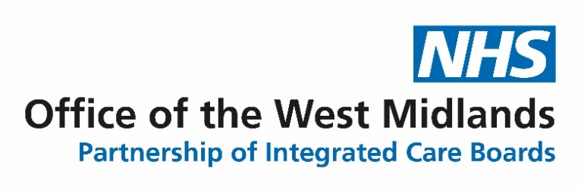

Office of the West Midlands
Operating Model

Guide on West Midlands Collaborative working arrangements

February 23

- Introduction

Since the inception of Integrated Care Boards organisations( ICBs) in July 22 there has been a clear focus on how health and care services are delivered in a more integrated way, both at place and across the Integrated Care System.
Over and above this work it has also become clear there is a growing need and benefit of working at scale across the six West Midlands ICBs covering :
- Birmingham and Solihull ICB
- Black Country ICB
- Coventry & Warwickshire ICB
- Hereford& Worcestershire ICB
- Shropshire & Telford & Wrekin ICB
- Staffordshire and Stoke ICB
The areas that ICBs have identified for collaborative working are :
- To manage the mobilisation and commissioning of delegated functions from NHS England (NHSE) with regard to Direct commissioning e.g. Pharmacy, Optometry & Dentistry( POD) and a sub set of specialised services
- To agree a West Midlands work programme for the ICBs where working together would add value and benefit for the population and the systems e.g. Commissioning Support Unit (CSU)
- To consider other functions and services that NHSE are reviewing for either delegation or transfer of hosting responsibility as part of their future design e.g. Cancer Alliance networks
This document aims to bring together in one document the operating model for the Office of the West Midlands( OWM).
This will cover:
- How the Office and lead director will operate and support the ICBs and wider partners
- How ICBs will make decisions together ,plan and oversee their work programme.
- How delegated functions and staff will be hosted and supported
The overall focus of the operating model will be to encourage and develop distributive leadership and expertise from each ICB and shared learning and development .

- Overall vision and core purpose

The ICBs have agreed an overall vision for the collaborative work of the West Midlands which is :
Through at scale collaboration and distributive leadership the Office of WM will add value and benefit to a shared set of common goals and priorities for West Midlands citizens and patients.
Its core purpose will be to :
- To commission a set of agreed functions at a West Midlands level on behalf of 6 ICBs through shared leadership and joint decision making
- To identify shared priorities and goals and clear projects and work programmes to deliver them
- To bring together in a single host ICB the shared teams and staff supporting the Office of the West Midlands and their ICBs.
- To develop distributive leadership and expertise across an agreed range of functions/teams for the benefit of all ICBs
- To provide a single coherent voice for the West Midlands ICBs where appropriate /a single point of contact/shared voice for change
- To share learning and support improvement across the ICBs
- To achieve best value and efficiency by working at scale where appropriate

- Work programme
An annual work programme will be developed and agreed by all ICB CEOs to deliver the key priorities identified from the above areas.
Appendix one details the draft 23/24 work programme to date .
It will be overseen through the West Midlands ICB CEO monthly meeting and project management will be co-ordinated through the OWM.
ICB CEOs will each take a strategic lead for overseeing a project across the West Midlands.

- Infrastructure and resources

- Office of the West Midlands( OWM)
A small central Office of the West Midlands will be established to support the work programme.
A Director of the OWM will be employed and they will work and support all of the ICB CEOs and be employed through a host ICB. They will :
- Oversee and manage the future development of the operating model and work programme. Additional project /admin support will be agreed as required.
- Oversee and manage the integrated staff hub ( Hosted through a single ICB) where all staff who support the delegated functions will be employed.
- They will line manage functional leads from these delegated functions and ensure they receive any support and guidance as required.
- In addition they will be a central point for ICBs and NHSE to link with in relation to the OWM and ensure there is clear and consistent communications.
This small function and resource will be supported through an agreed MOU across the ICBs. ICBs will agree an annual allocation resource to support the OWM and will be reviewed each year.
- Distributive Leadership
The CEOs have agreed that leadership and support to the OWM work programme and to the delegated functions will be provided by all of the ICBs.
- West Midlands agreed projects /functions
Each ICB CEO will be identified to be a strategic lead /sponsor of an area of the OWM work programme.
This will involve the CEO either chairing a task group ( such as CSU Task Group) or co-ordinating a consistent voice /developing a strategic approach. They will be the point of escalation for any significant issues in that area.
All projects will aim to involve expertise and skills from across the ICBs at all levels .
-NHSE delegated functions /teams
In addition for the delegated NHSE functions there will also be an ICB CEO lead providing strategic support to the function and to co-ordinate any strategic discussions or escalations. (Either with ICB CEOs or NHSE)
The Director of OWM will act as the key co-ordination point for any request for support/advice.
They will not deal with day to day operational issues within the function as they will be managed through the Head of function or the Director of OWM if they require more senior support. .
The functional staff and team will be managed under the Director of Office of West Midlands.
To date it has been agreed Hereford & Worcestershire ICB CEO will be the strategic lead for POD services.
- Host ICB for the integrated staff Hub
For all of the transferring staff and teams for any of the delegated functions it is proposed that they will be employed through one single ICB. The integrated staff hub will be managed centrally through the Director of OWM.
The benefit of centralising this role will be that all of the corporate support can be focused through one host ICB route which will add value and can gain the benefit of working at scale.
The host ICB will provide the following support :
- Employer of staff
- Agreement on the provision of corporate support – HR, legal, OD ,procurement, IT etc
- Agreement on location for the teams/staff is being finalised but is proposing that staff will have the option to agree to work from either NHSE offices, ICB offices or hybrid/ home – as agreed with line manager .Opportunities for face to face development of teams in the office will be available and agreed.
The host ICB will not make any commissioning decisions and will focus on the generic corporate support only.
The host ICB will be BSOL ICB
- Timetable for delegation of functions/staff
The timetable for delegated staff /functions being hosted through BSOL ICB is :
Function | Commissioning  Transfer | Staff Transfer to BSOL host
WM POD commissioning/GMAST & finance team | April 23 | July 23
WM Primary care complaints team | April 23 | July 23
Midlands Specialised Commissioning & finance team | April 24 | April 24

*Other functions being considered – Cancer Alliance ,LTC networks, Immunisation & vaccination
- POD (Pharmacy, Optometry & Dentistry- including secondary dental services)
ICBs will be commissioning a number of community primary care services and contracts from April 23 including:
Function
General Dental services (dental surgeries)
Community Pharmacists (mainly chains/high street)
Optometrists (mainly High street)

Secondary Dental including :

Inpatient dental services – Orthodontics, Oral surgery, oral medicine, maxillofacial surgery and restorative services

A single West Midlands POD commissioning/finance team will be TUPE transferred to the host ICB and managed by the OWM from July 23.
The associated complaints team support to all of the primary care functions will also transfer – POD and General Practice
In addition the General Practice team supporting ICBs ( GMAST) in areas such as estates will also be delegated from July 23 and hosted through BSOL ICB.
The GMAST team will provide the commissioning expertise and knowledge to the ICBs and support the joint arrangements.
- Specialised services
There are in total 146 services who are described as specialised within six care programmes-cancer, women’s & children, mental health, Trauma, Blood & Infection and Internal medicine.
. These services will be commissioned by three different commissioners in future:
- Tier 1 -Highly specialised services – National NHSE function
- Tier 2- regional specialised services -sub set of services to continue to be commissioned through NHSE Midlands ( no timeline agreed for transfer to ICBs)
- Tier 3-ICB specialised services -A sub set of specialised services to be commissioned by ICBs collaboratively across West Midlands from April 24.
During 23/24 ICBs will be involved in jointly planning with NHSE Tier 3 services but not fully accountable until 24/25.
A single midlands commissioning team will support both the regional NHSE midlands commissioning function as well as both East and West Midlands led commissioning functions
The whole Midlands team will be hosted by BSOL ICB.
To support the Midlands arrangements there are a wide number of clinical networks and operational delivery networks.

- Governance and decision making

- Office of West Midlands
The 6 ICBs will discharge its duties and ensure collective decision making is undertaken through a clear set of governance arrangements as set out in appendix Two/Three .
In summary :
- Joint committee of ICBs- Tier 1
The role of the Joint Committee is to provide strategic decision-making, leadership and oversight for the Joint Working and Joint Commissioning services and any associated activities.

The meeting will be split into two parts and one part will be to focus on ICB business only – including decisions on delegated functions/West Midlands work programme

Part two will include NHSE and will focus on specialised commissioning where we will be planning and jointly working together during 23/24.

- West Midlands CEO meeting
The CEOs will meet monthly to oversee the development of the Office of the West Midlands and its operating model .
In addition the group will oversee the work programme and also be a point of escalation for any strategic issues which cannot be resolved through normal governance routes.
This will be supported by the Director – Office of West Midlands
A standard briefing note will be issued out after each meeting to the ICBs to ensure clear communications through to each ICB Executive Team.
- Operating model group
Phil Johns ICB CEO for Coventry & Warwickshire ICB is leading a group of Directors across all 6 ICBs to develop the future operating model. The Director representatives will be the link within each ICB during mobilisation.
This group reports through to the ICB CEO meeting.
- Functional commissioning groups ( Tier 2 )
The routine business and collaborative commissioning of services will be enacted through a number of groups including :
- West Midlands POD Joint commissioning group( JCG)
- Formal Midlands Acute Specialised commissioning group ( FMASCG)
These will need Director level representation from ICBs.
- Service specific operational groups( Tier 3)
These groups will provide service specific advice and support to the ICBs around delegated areas such as :
- Pharmaceutical services Regulations committee
- Dental Assurance and Information Committee(DAIC)
- Other appropriate working groups
Each ICB will identify and nominate operational leads to sit on the various groups as required
In addition other task groups relating to the OWM work programme will be finalised – at the moment these include the CSU task group led by Simon Whitehouse ( ST&W ICB)

- 23/24 mobilisation plan ( Time limited )
- ICBs
All ICBs will be ensuring there is clear oversight and due diligence within their local governance to take on the commissioning of the NHSE delegated services.
This normally takes the format of a delegation oversight group.
All ICBs will need to ensure their NEDS and ICB Boards are well briefed and aware of the future service transfers
The Director OWM will provide a forward look and consistent briefing material and papers to support the ICBs mobilisation plans
- Functional specific mobilisation ( WM/EM)
In addition there will be time specific mobilisation plans across the Midlands for functional delegations such as POD and specialised services.
Appendix three details the governance for the POD mobilisation .

- Communications
To communicate with the OWM please email: office.westmidlands@nhs.net

- Review
The Operating Model will be reviewed after an initial six month period .

Area | Topic | Timescale | ICB Lead
NHSE/E delegation | • POD Commissioning & Complaints  • Specialised Services  • Spec MHLDA  • Immunisation & Vaccination  • Potential Areas for delegation: Cancer Alliance, Clinical Networks, Workforce, Transformation | April 23 (Staff July 23)  April 24 (Staff April 24)  April 24  To be agreed/discussed | H&W ICB Strategic Lead  BSOL ICB Midlands Host ICB  TBC  TBC
Establishment of WM Office and integrated staff hub | Operating model to be agreed  Establishment of integrated staff hub | April 23  April 23 | PJ to lead WM op model group  Interim WM Dir
111/999 | Procurement of Midlands 111 | TBC | BC ICB
CSU review and Task Group | Review of opportunities across CSU contracts  Link with national review/NHSE/I | TBC | S&T ICB
West Midlands Dental Review | CSU led review of economics of dental services across West Midlands | March 23 | Directors of Primary Care Group / H&W ICB
General practice | Learning/sharing good practice/new operating models | Ongoing – workshop held | Directors of Primary Care ICBs
Other suggested topics for 23/24 or more longer term | • Efficiencies and productivity  • West Midlands Combined Authority link  • Workforce planning  • Provider Collaborative development  • UEC Control room- centralised support (L/T)  • Digital – remote community support (L/T)
Appendix 1

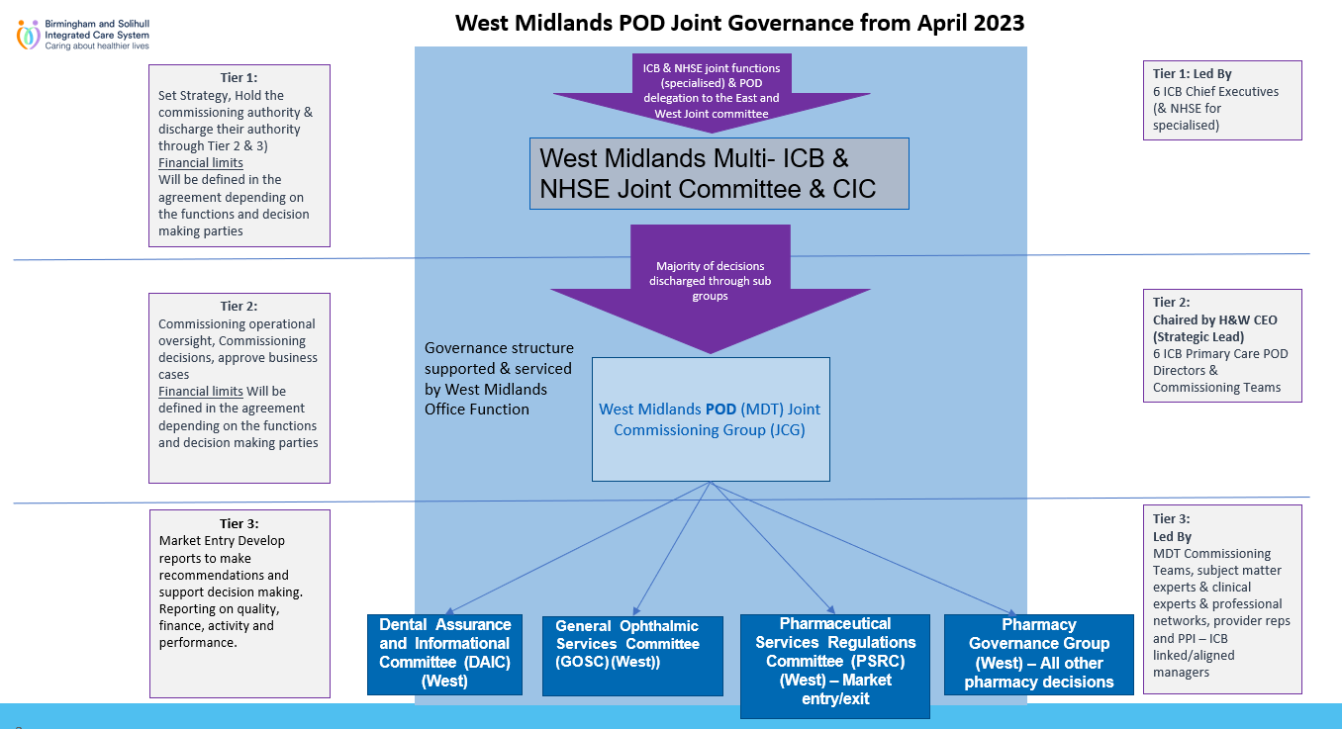

Appendix 2


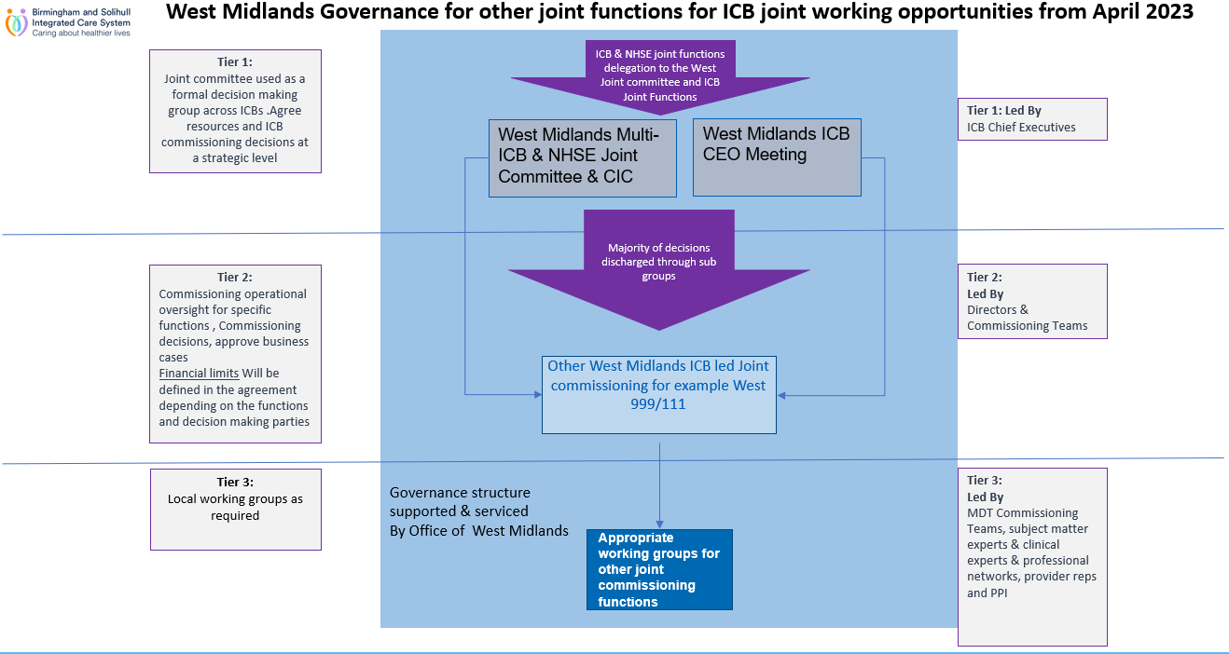

West Midlands Integrated Care Boards Working Together
NHS Birmingham and Solihull ICB / NHS Black Country ICB / NHS Coventry and Warwickshire ICB / NHS Shropshire, Telford and Wrekin ICB /
NHS Staffordshire and Stoke-on-Trent ICB / NHS Hereford and Worcestershire

office.westmidlands@nhs.net

